**MongoDB**

**Query / Find Documents**

Query the **movies** collection to

1. Get all documents

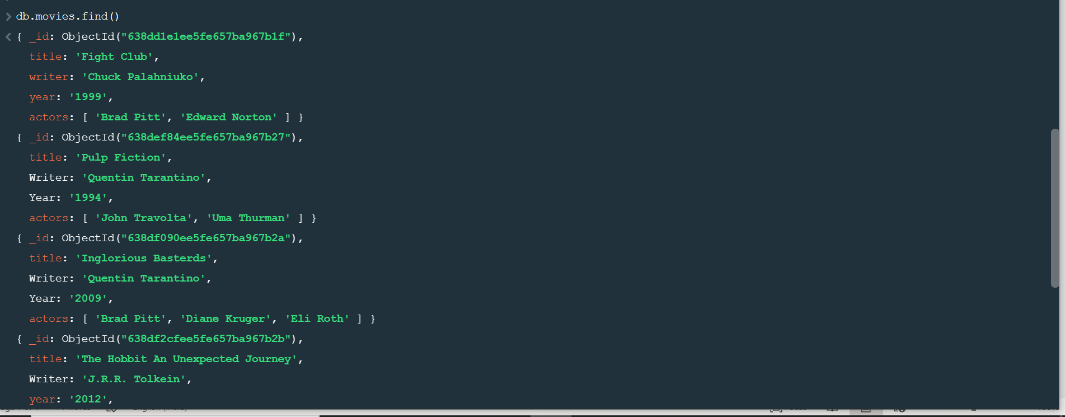

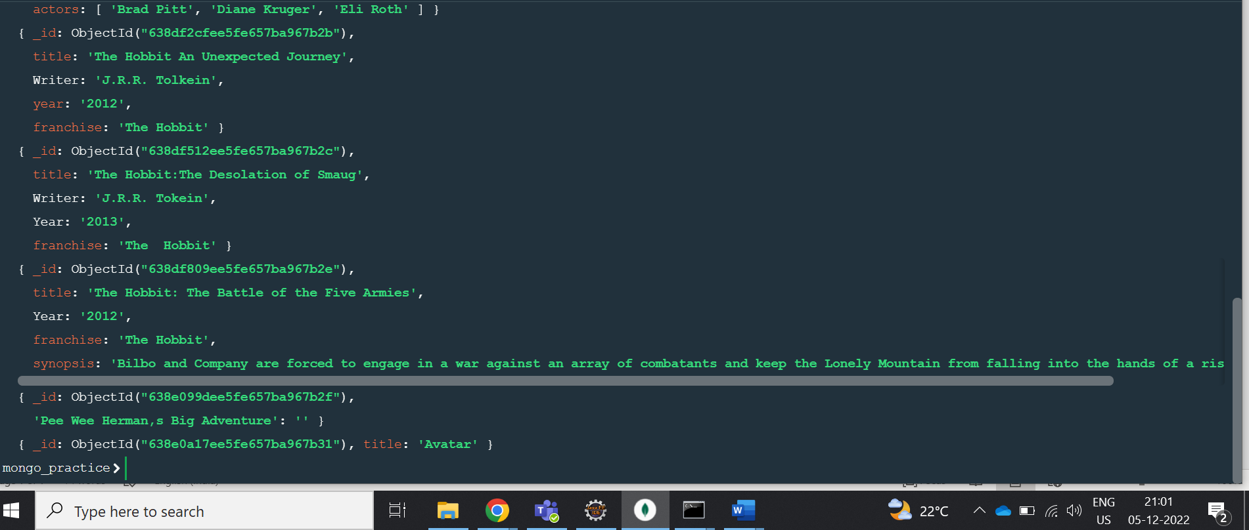

2. Get all documents with writer set to “Quentin Tarantino”

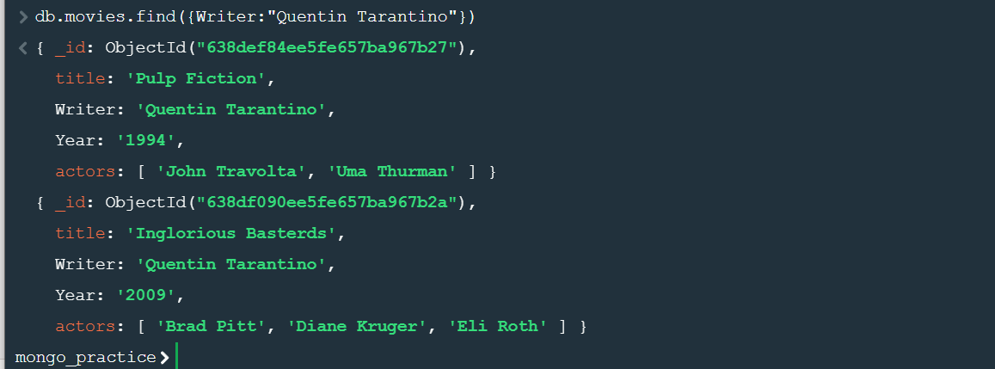

3.Get all documents with Where actors include” Brad Pitt”

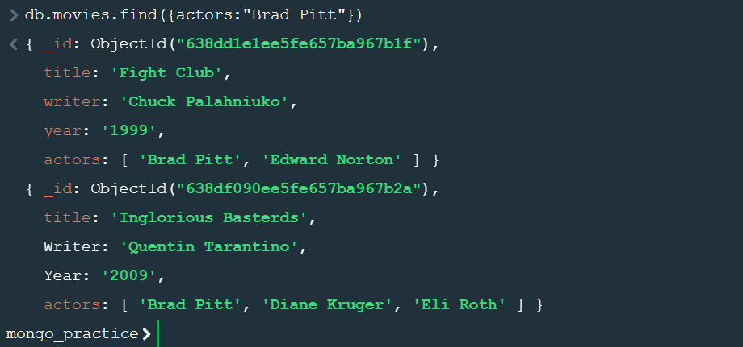

1. Get all documents with franchise set to “The Hobbit”

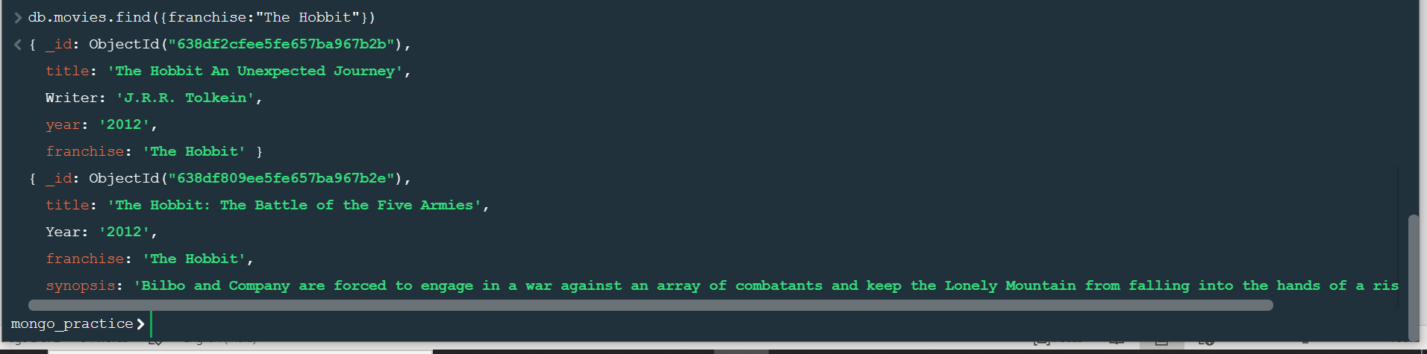

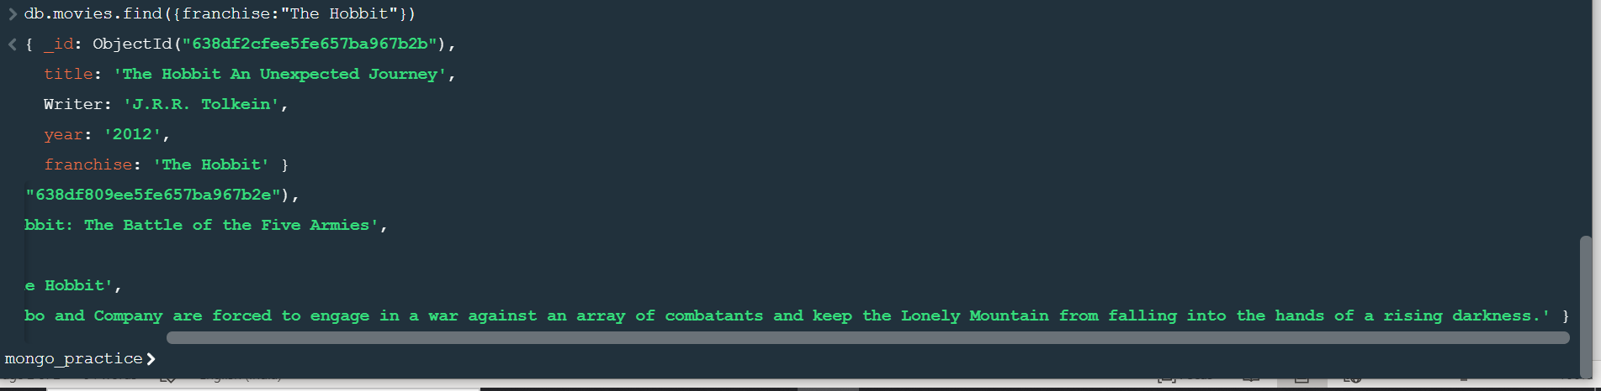

1. Get all movies released in the 90s



1. Get all movies released before the year 2000 or after 2010

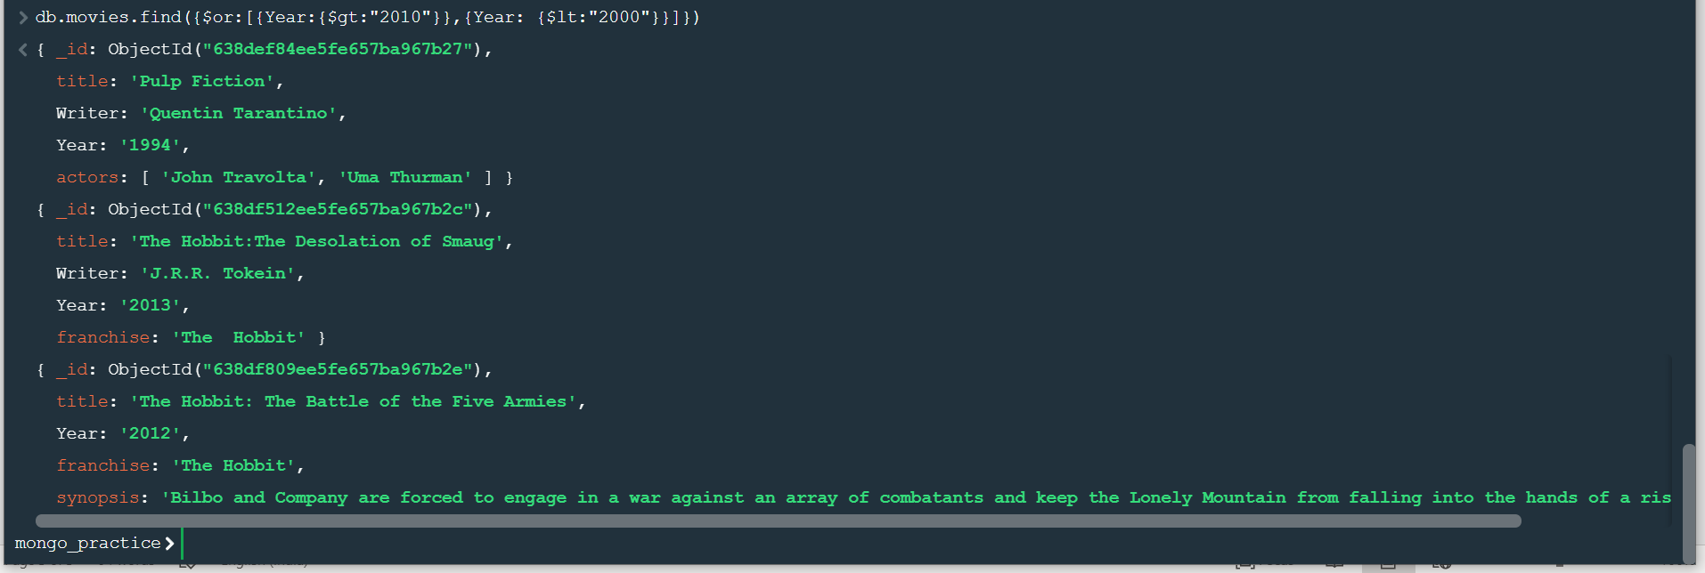

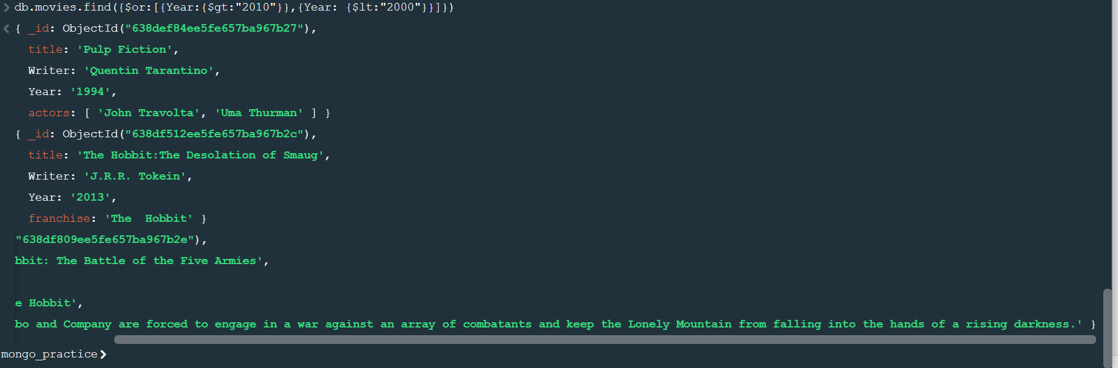

Update Documents

1. Add a synopsis to “The Hobbit: An Unexpected Journey”: “A reluctant hobbit Bilbo Baggins, sets out to the Lonely Mountain with a spirited group of dwarveps to reclaim their mountain home – and the god within it – from the dragon Smaug.”

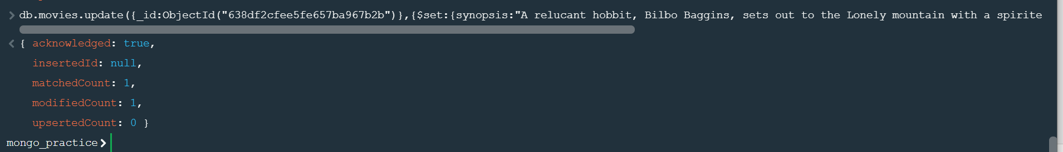

1. Add a synopsis to “The Hobbit: The Desolation of Smaug”: “The dwarves, along with Bilbo Baggins and Gandalf the Grey, continue their quest to reclaim Erebor, their homeland, from Smaug. Bilbo Baggins is in possession of a mysterious and magical ring.”

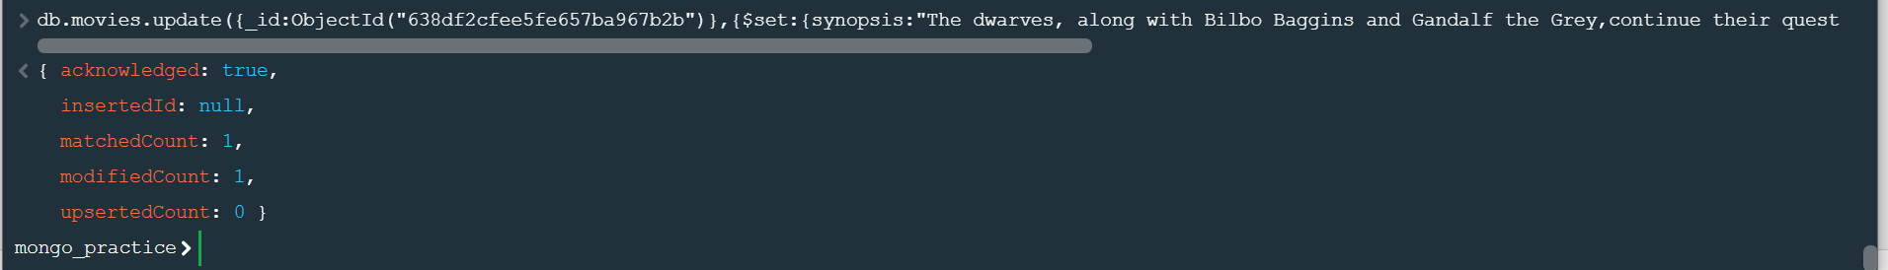

1. Add an actor named “Samuel L. Jackson” to the movie “Pulp Fiction”

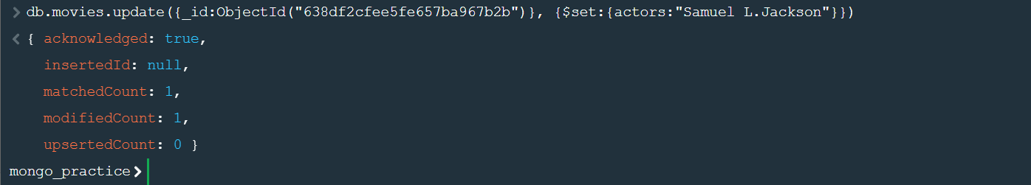

TEXT SEARCH

1. Find all movies that have a synopsis that contains the word “Bilbo”

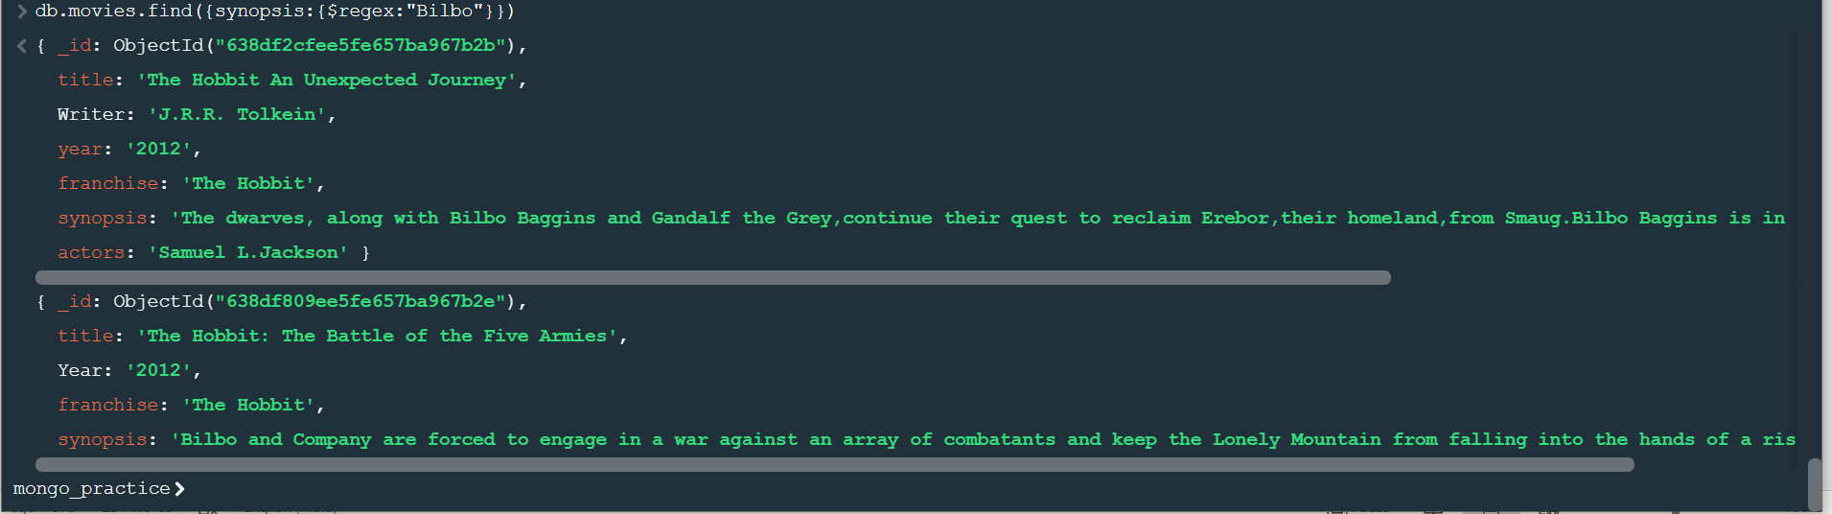

1. Find all movies that have a synopsis that contains the word “Gandalf”

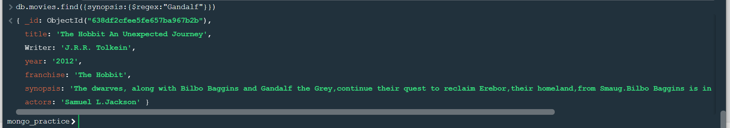

1. Find all movies that have a synopsis that contains the word “Bilbo” and not the word “Gandalf”

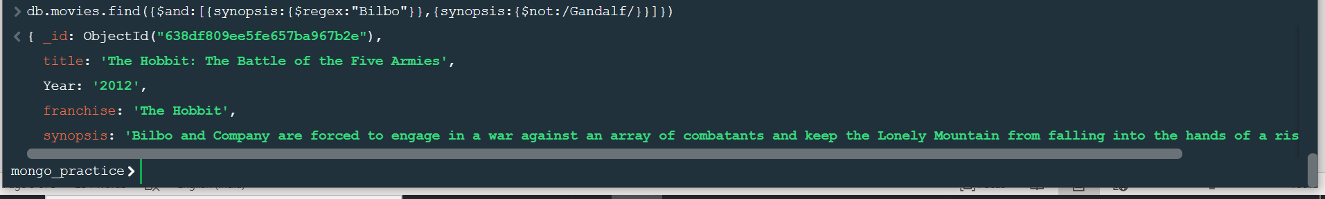

1. Find all movies that have a synopsis that contains the word “dwarves” or “hobbit”

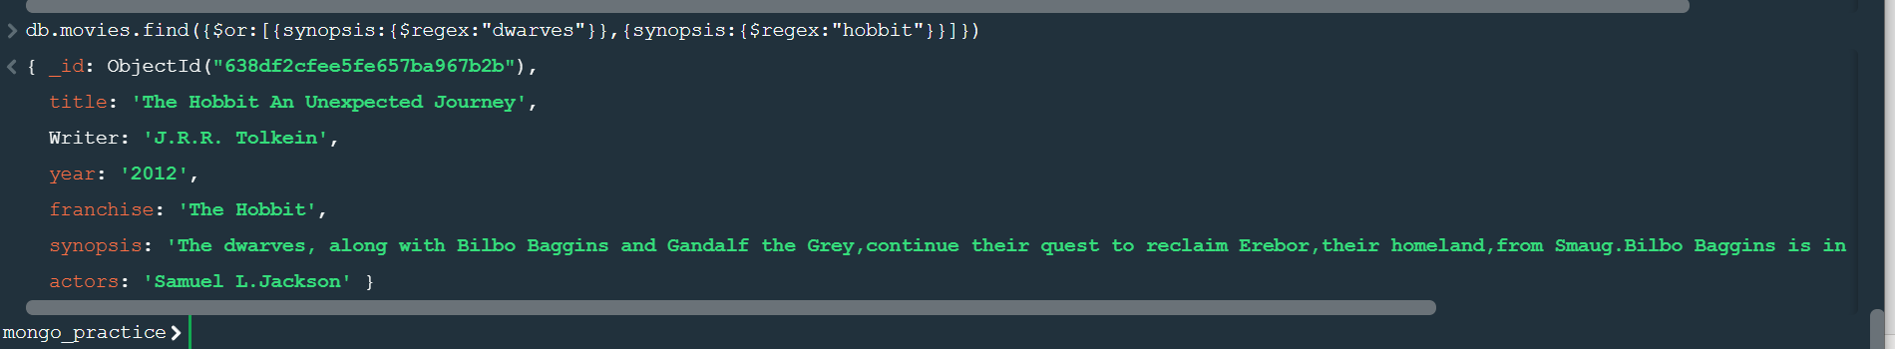

1. Find all movies that have a synopsis that contains the word “gold” and “dragon”



**Delete Documents**

1.delete the movie “Pee Wee Herman’s Big Adventure”

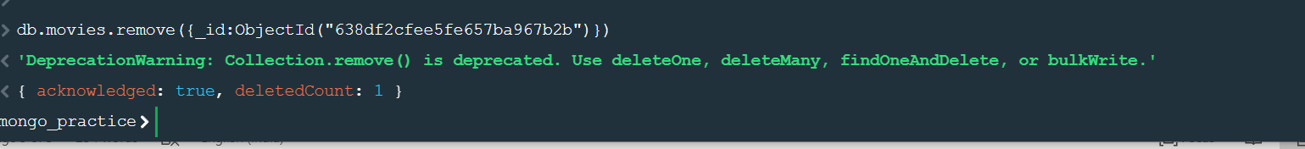

2. delete the movie “Avatar”

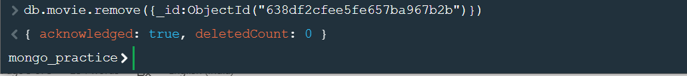

**Relationships**

**Querying related**

1.find all users



2.find all posts

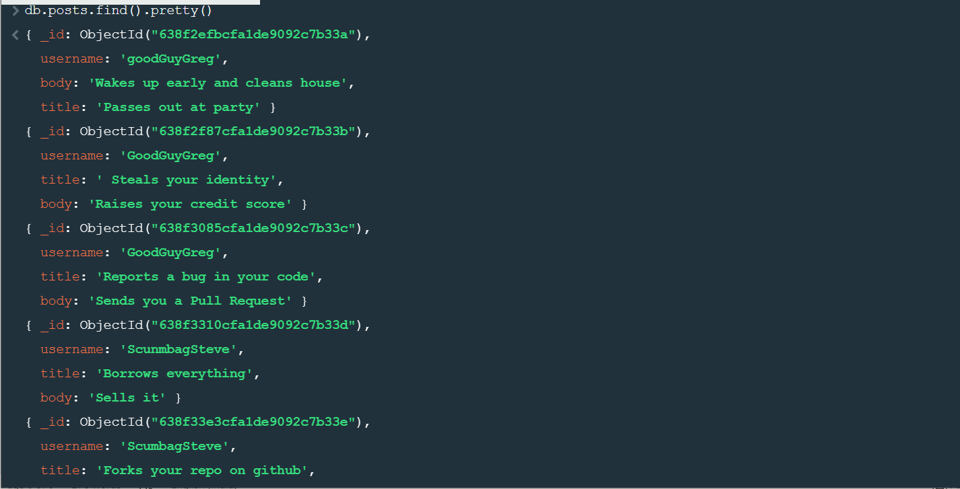

3.find all posts that was authored by ”GoodGuyGreg”



4.find all posts that was authored by “Scumbagsteve”



**Assignment-2**

1. Use db.Zipcodes.find() to filter results to only the results where city is ATLANTA and state is GA

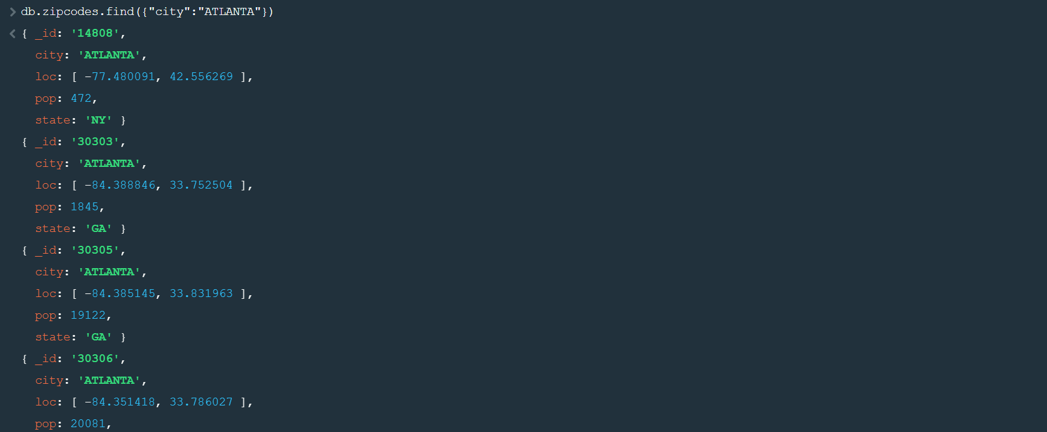

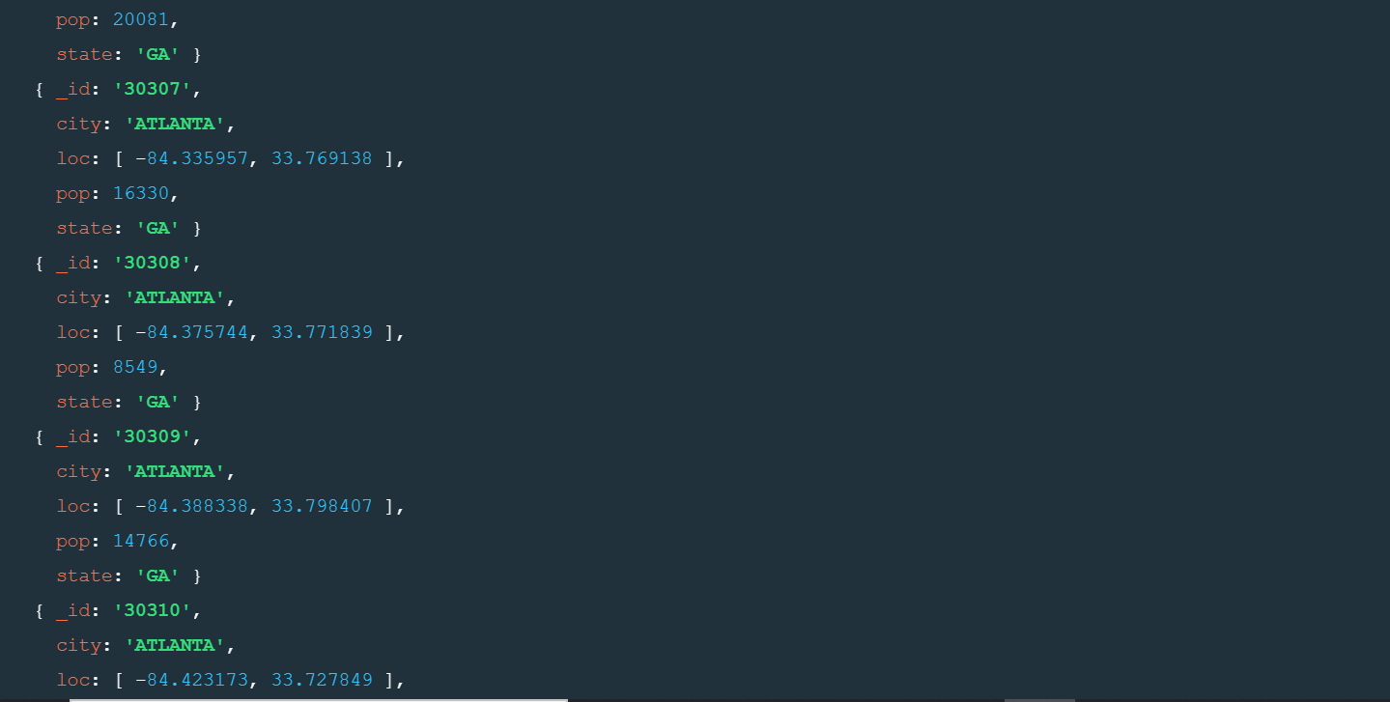

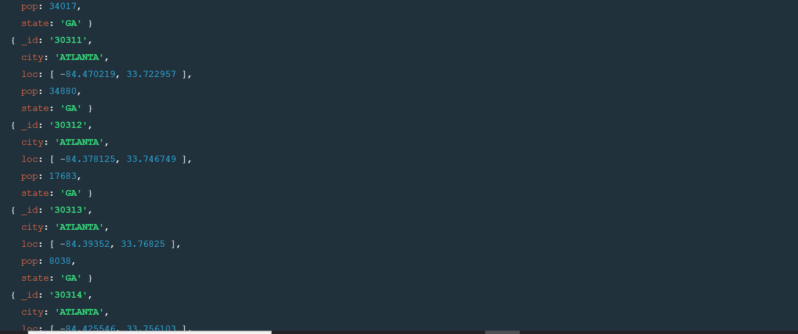

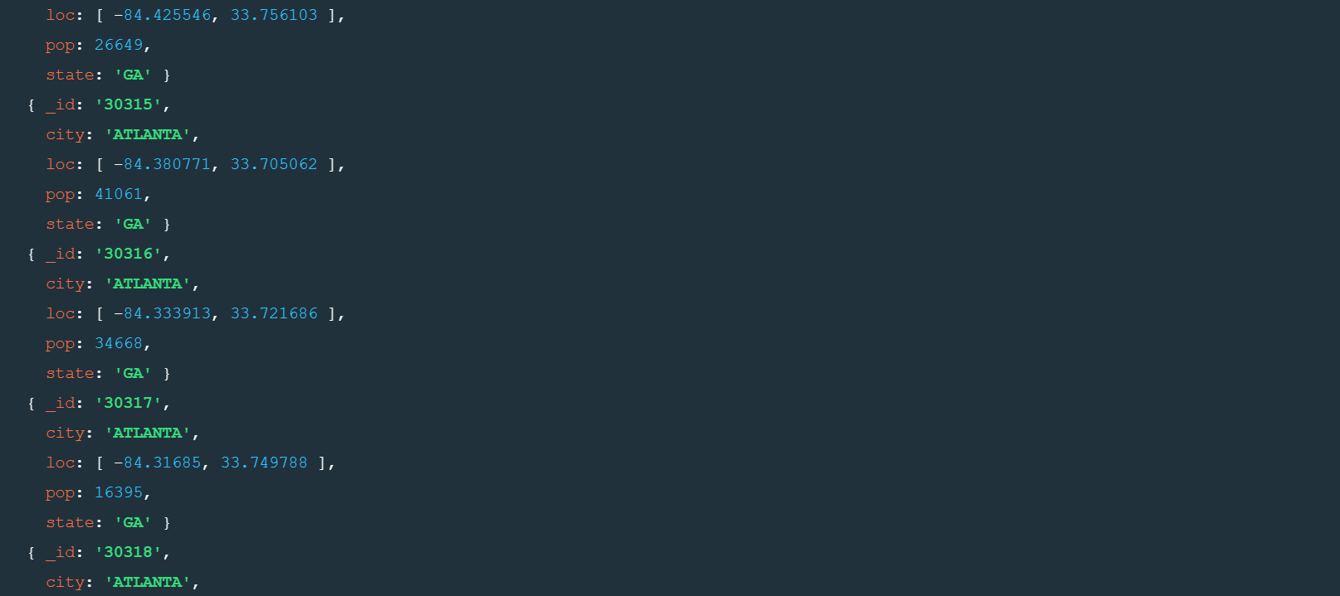

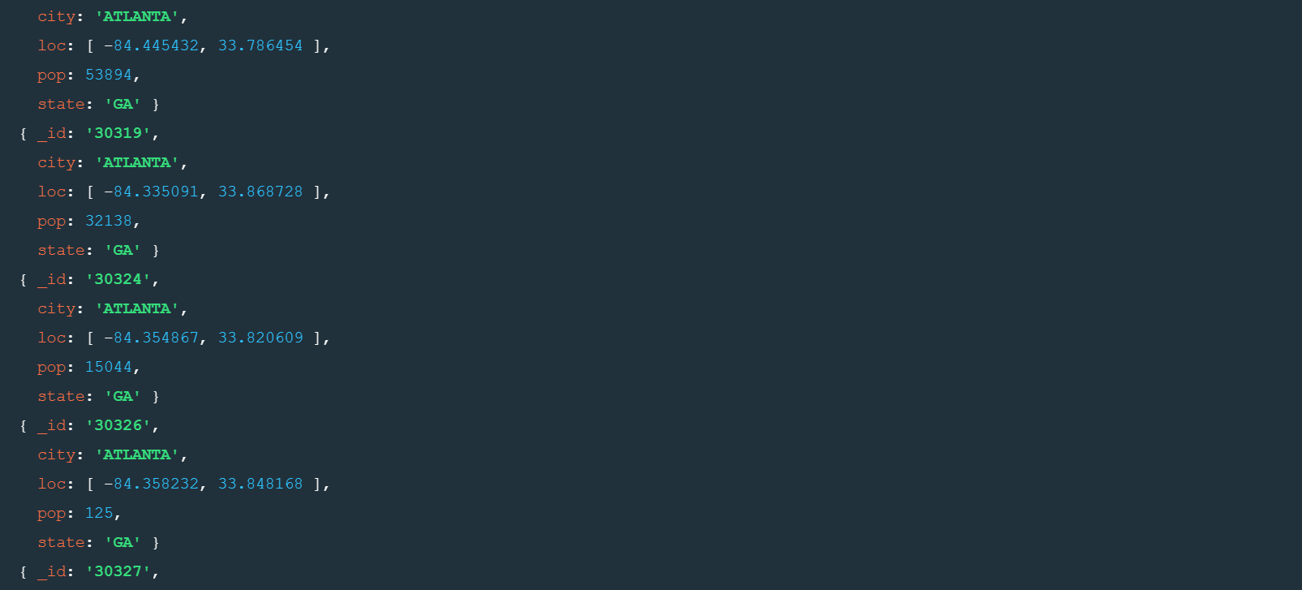

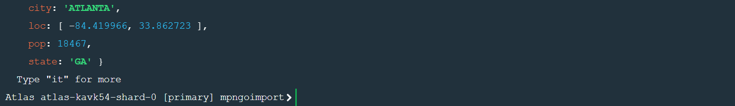

1. Use db.Zipcodes.aggregate with $match to do the same as above

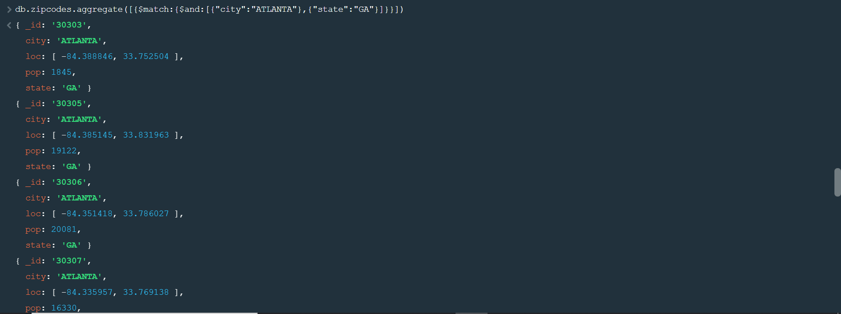

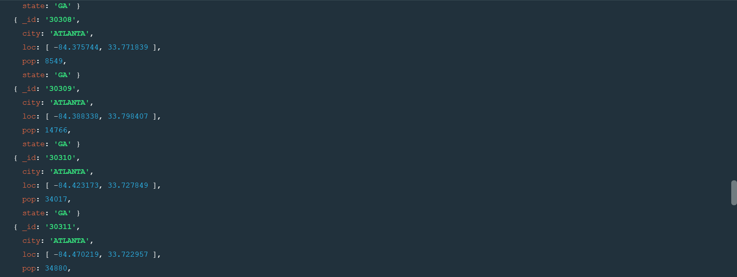

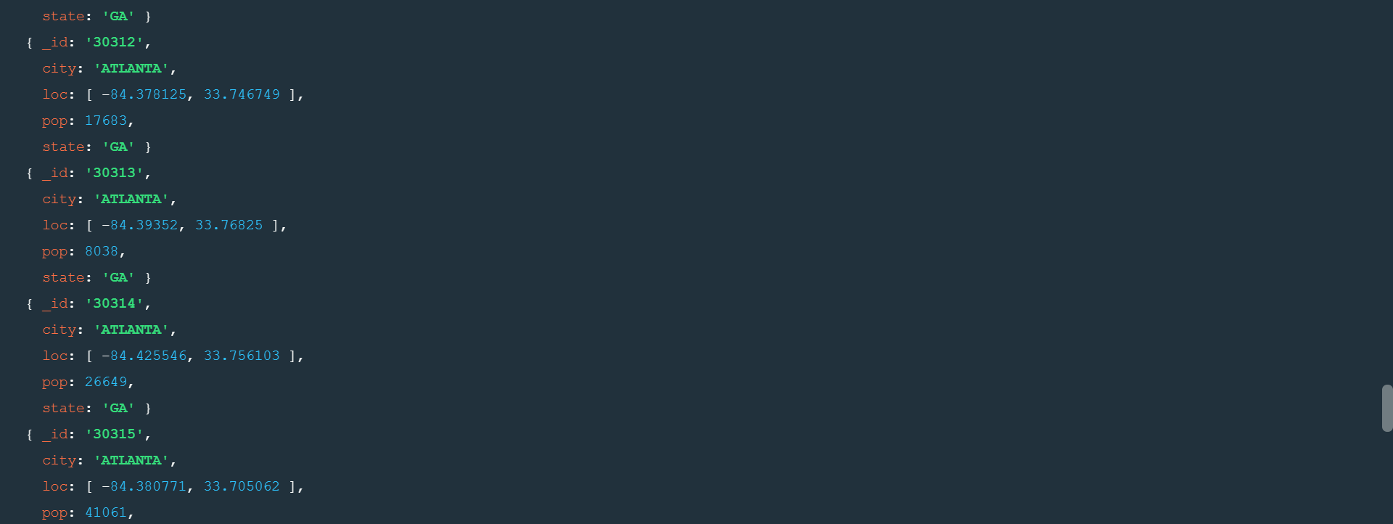

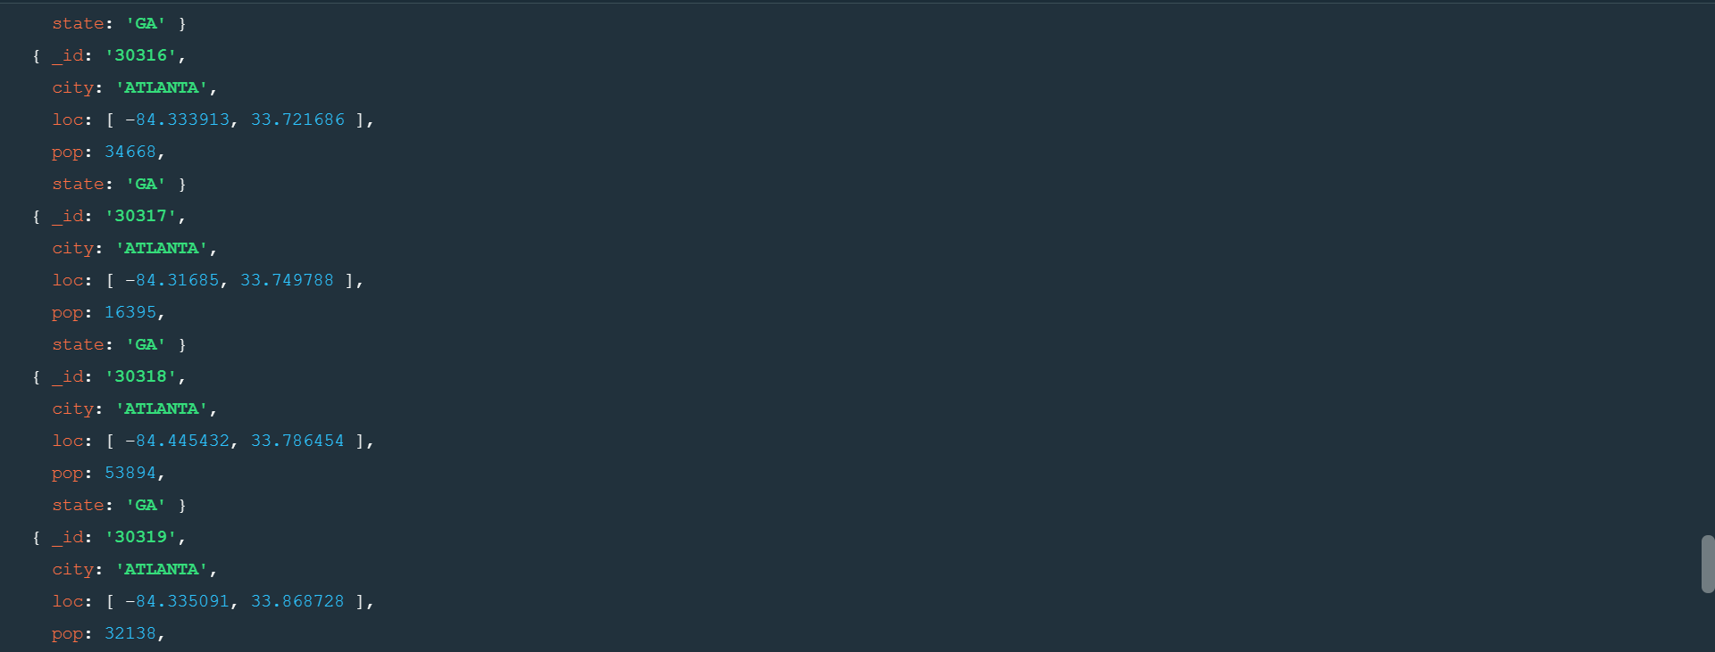

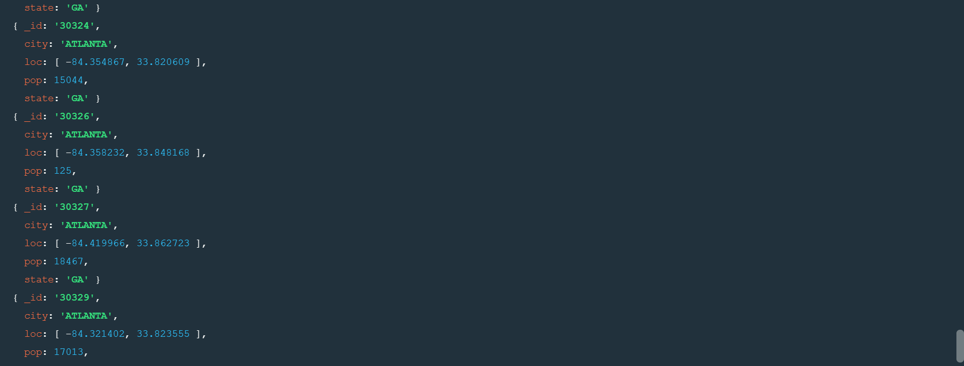



3.Use $group to count the number of Zip codes in Atlanta.



4.Use $group to find the total population in Atlanta.



**Population by state**

1.User aggregate to calculate the total population for each state



2.sort the results by population, highest first

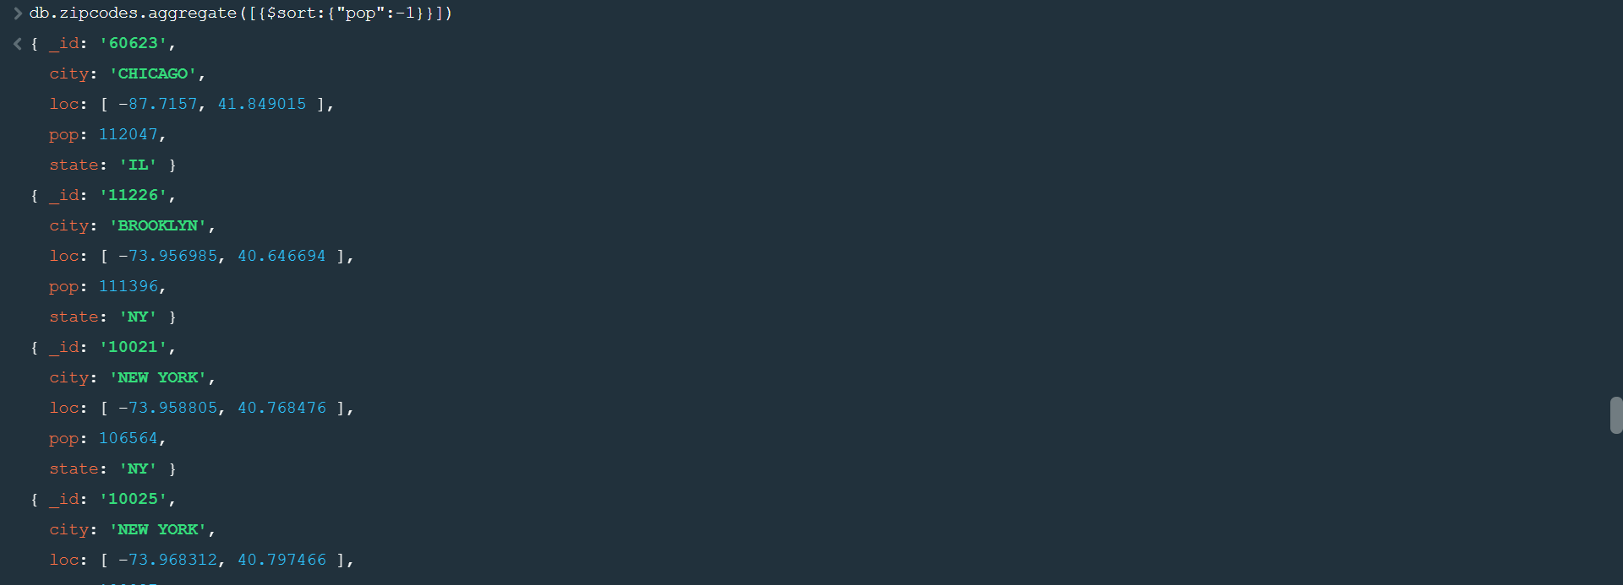

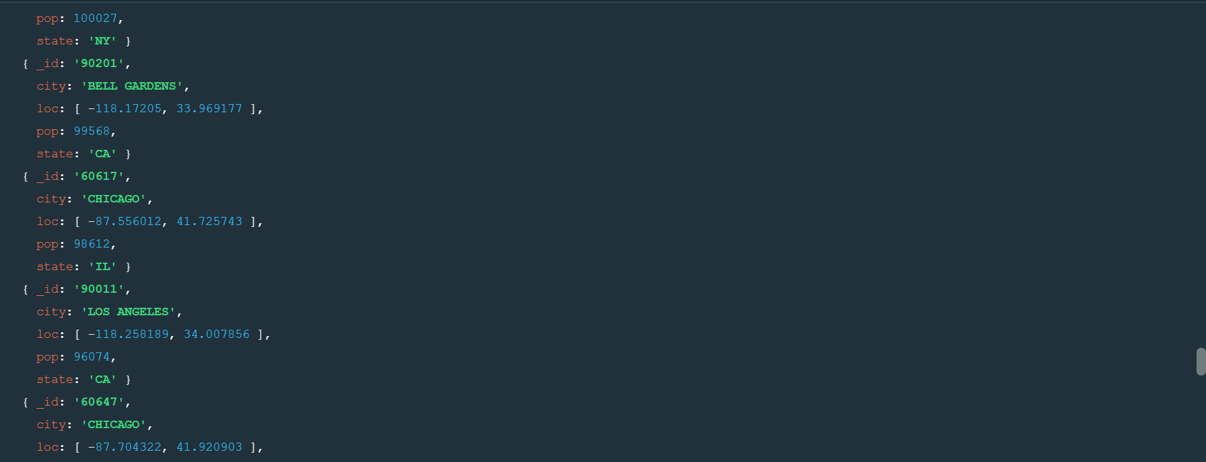

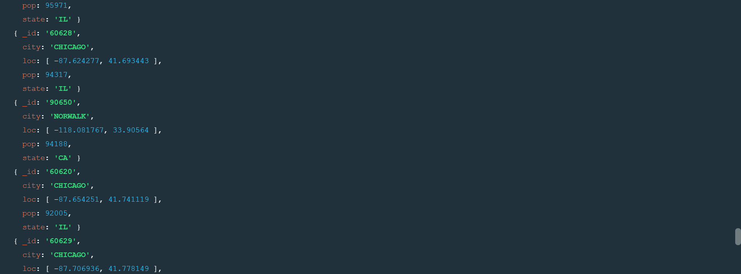

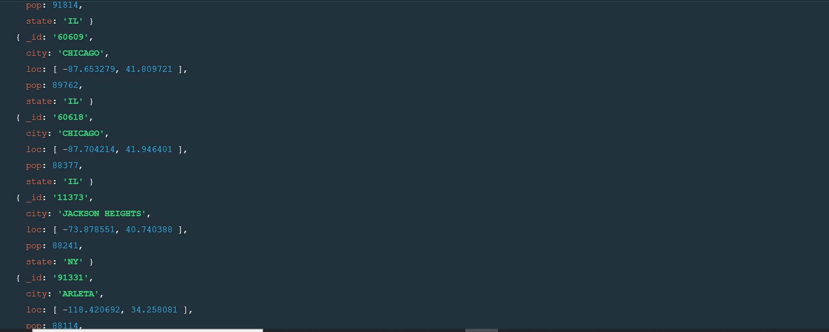

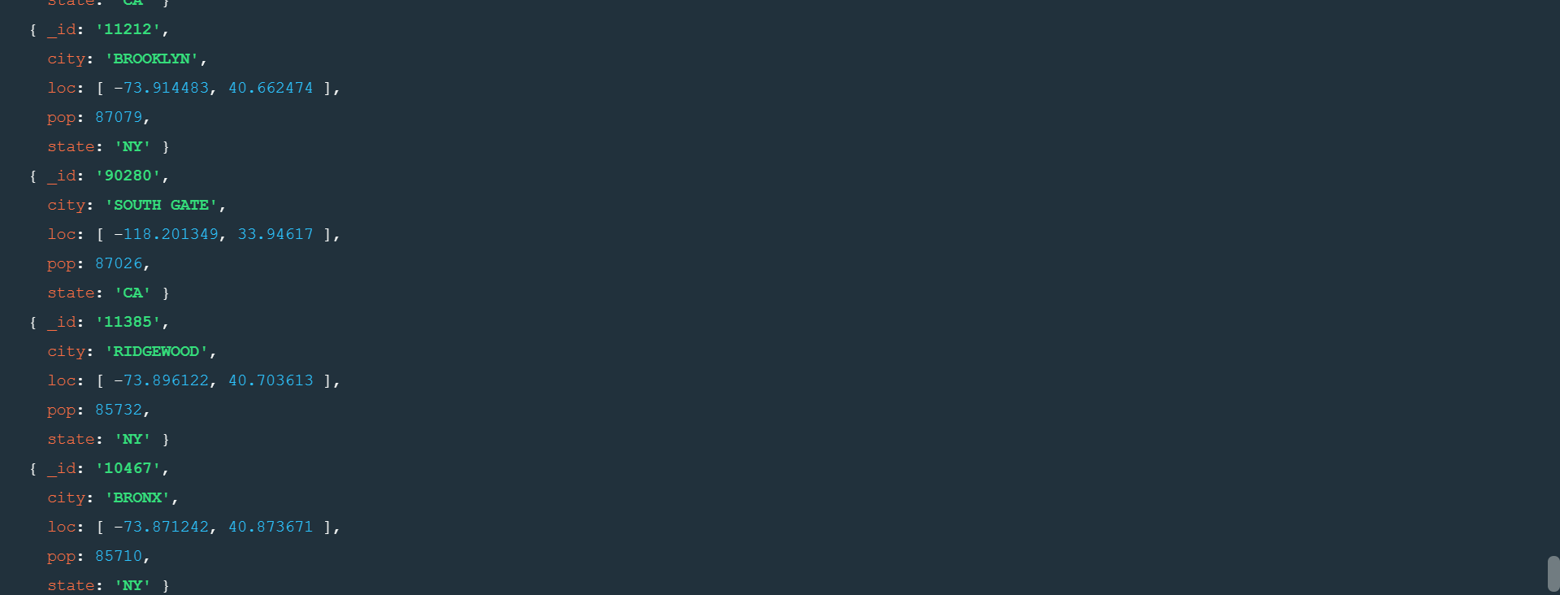

3.limit the results to just the first 3 results. What are the top 3 states in population?

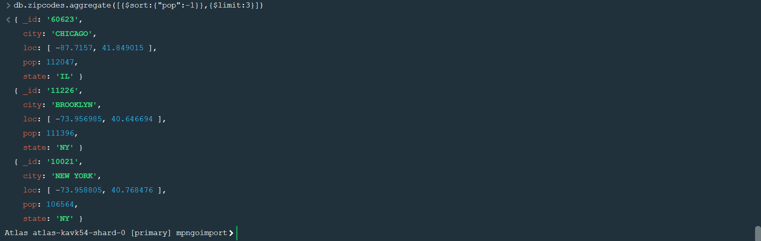

**Population by city:**

1.Use aggregate to calculate the total population for each city (you have to use city/state combination for the _id of the $group:{city:’$city’, state: ’$state’}



2.Sort the results by population, highest first

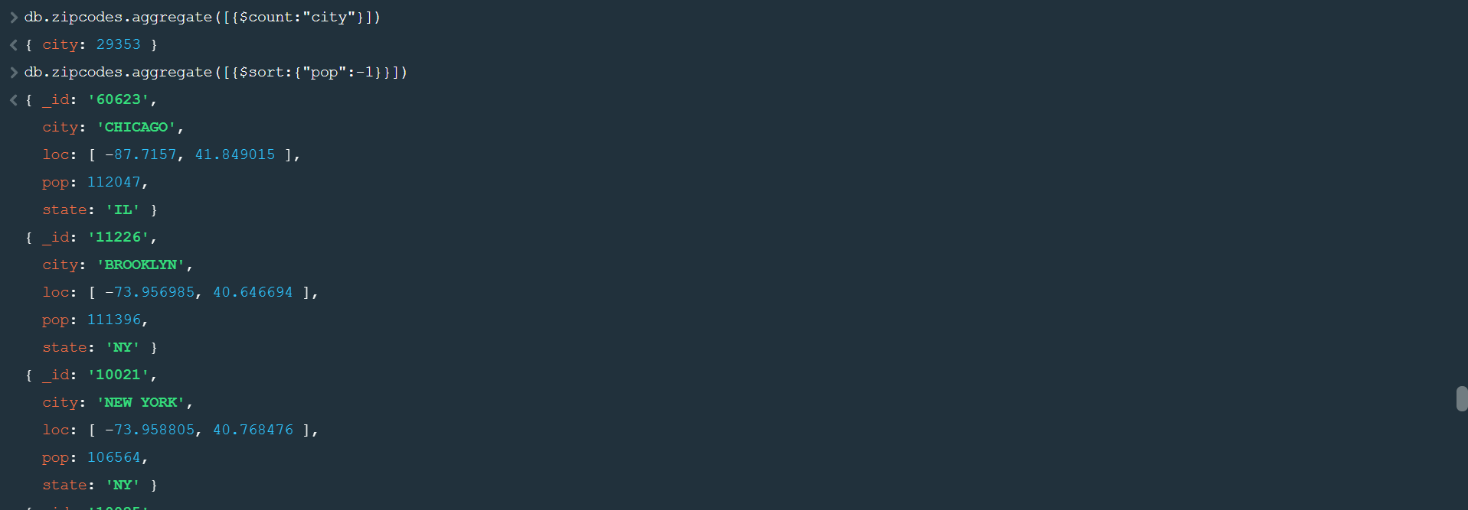

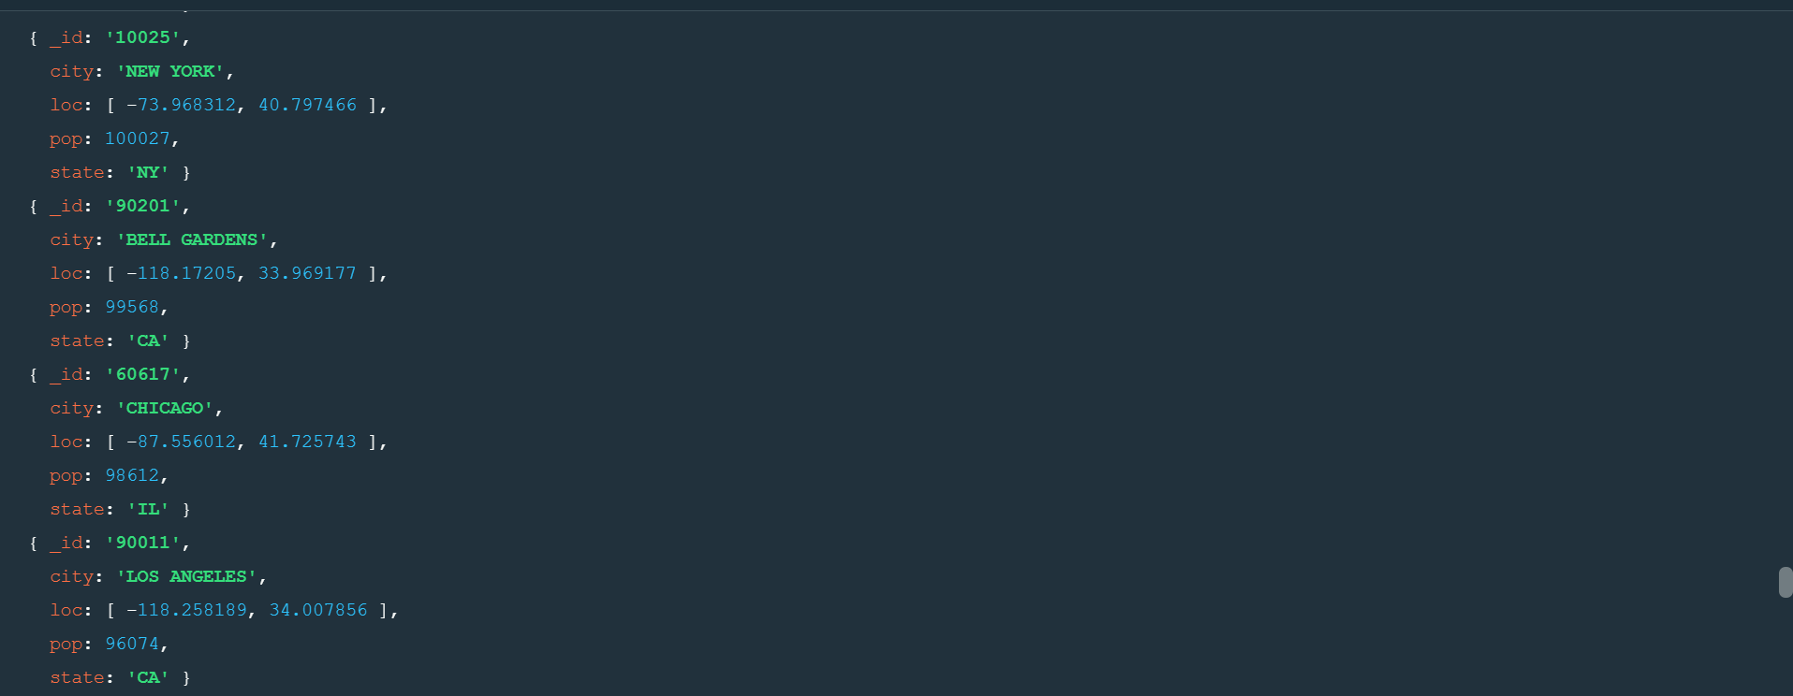

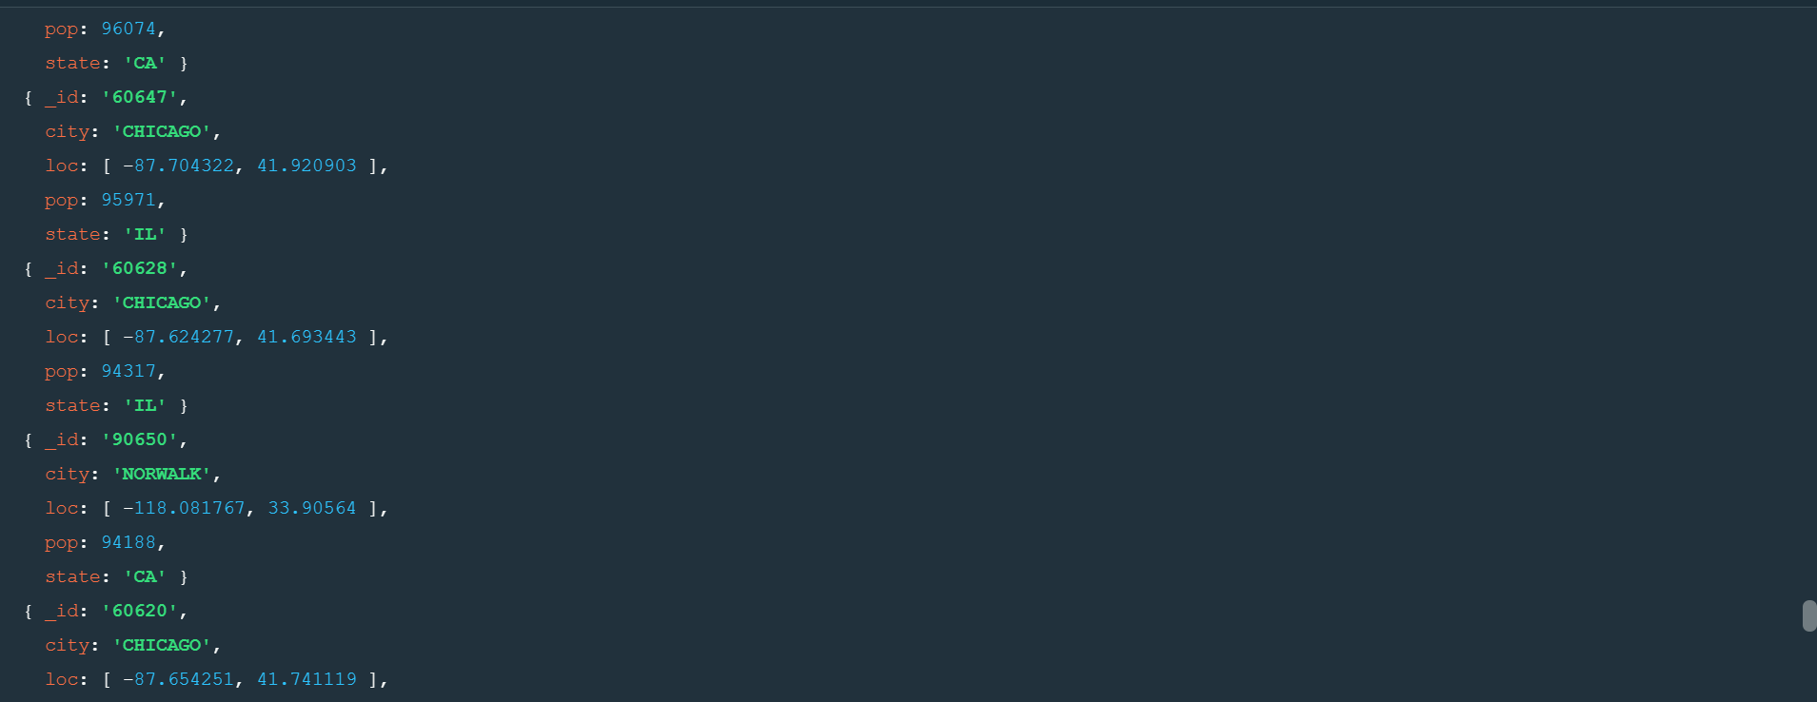

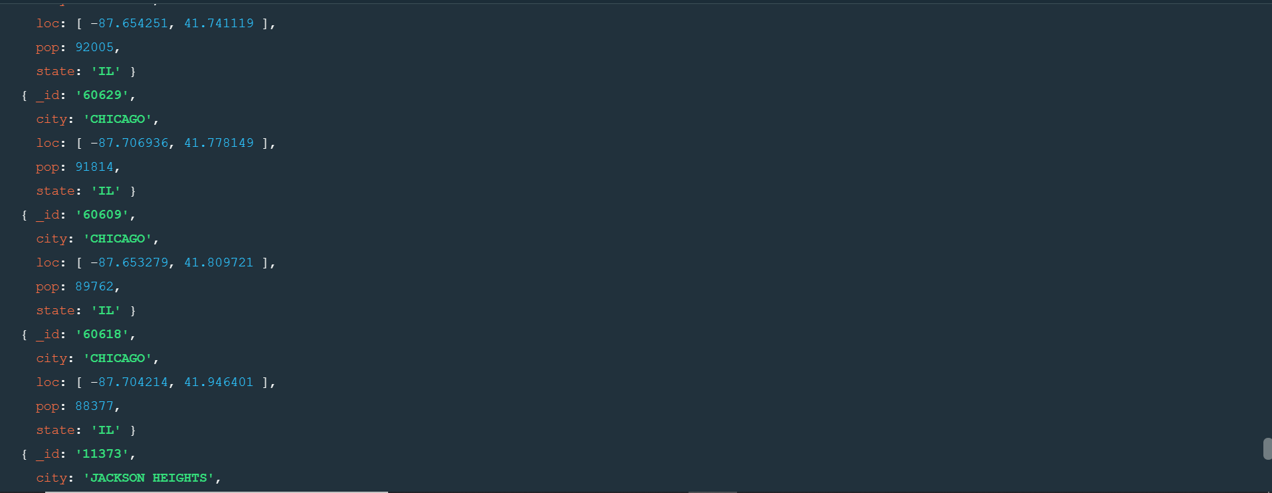

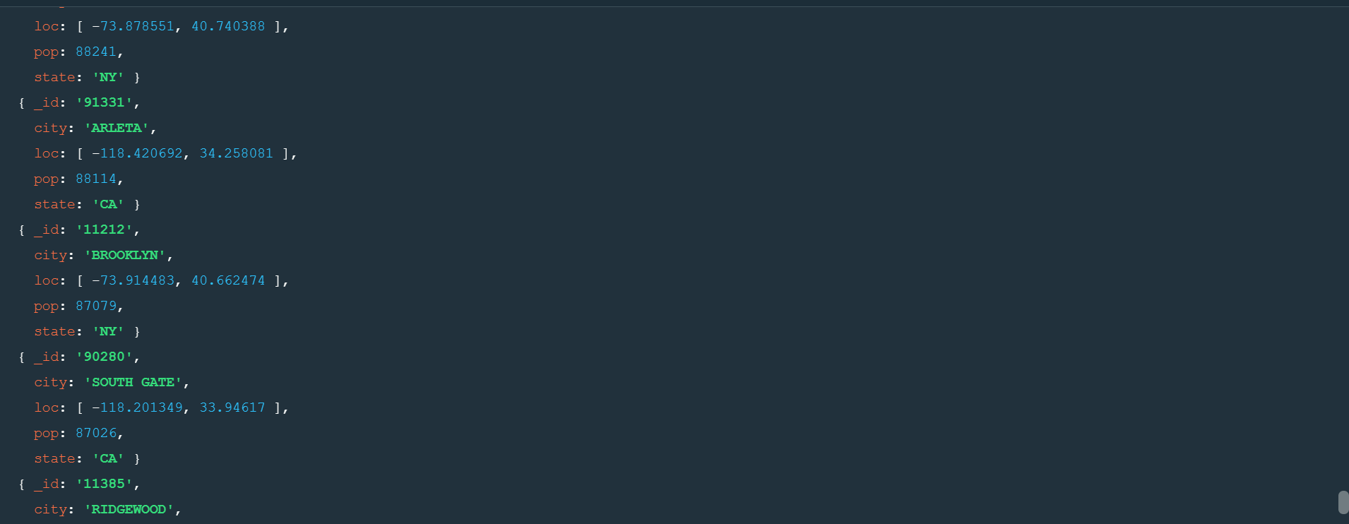

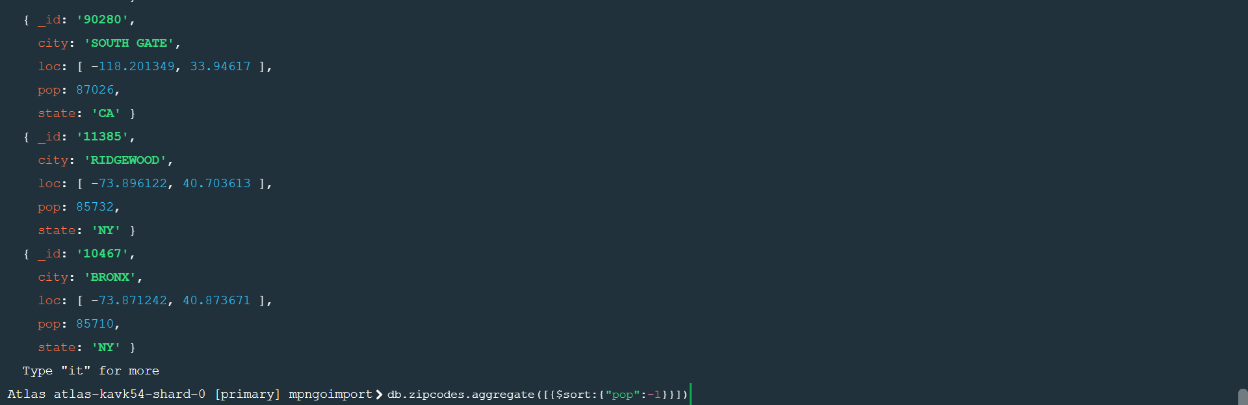

3. limit the results to just the first 3 results. What are the top 3 cities in population?

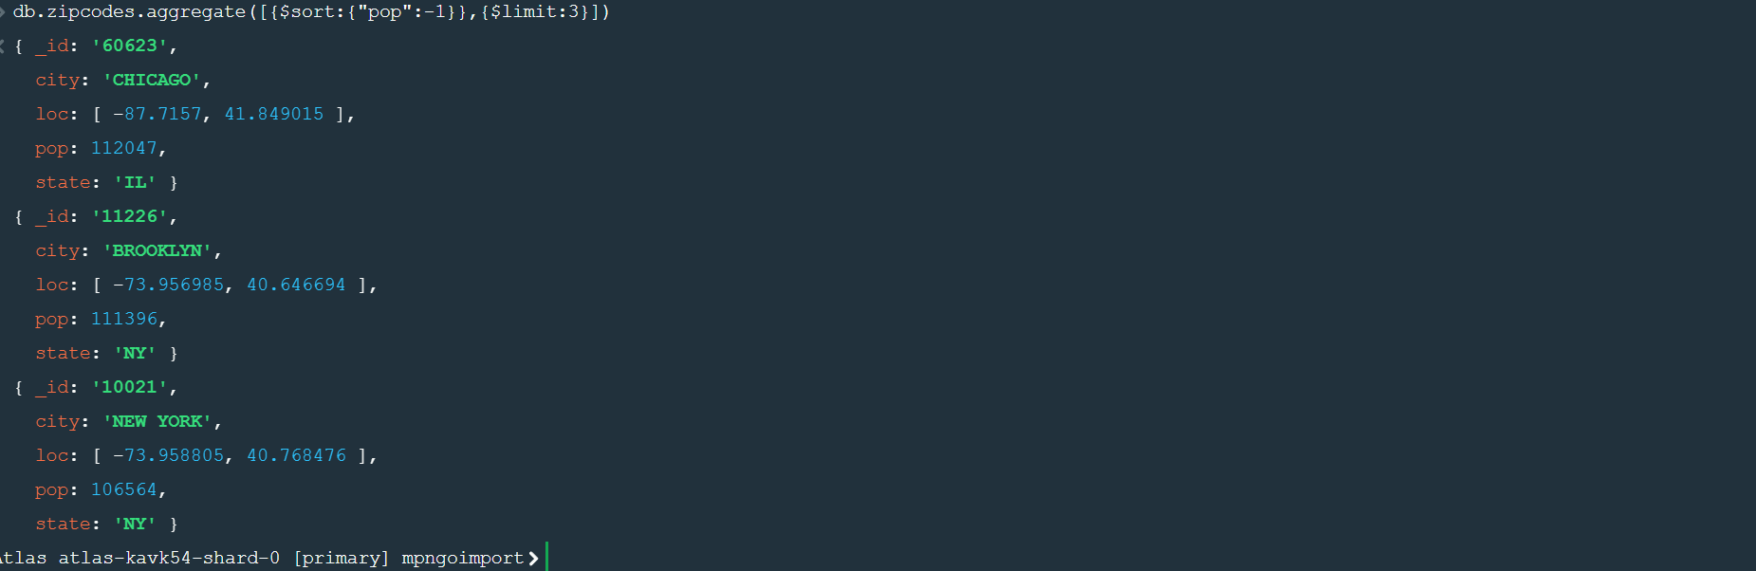

4.What are the top 3 cities in population in Texas?

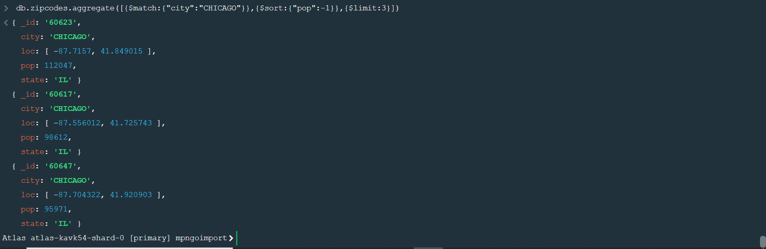

**Bonus:**

1.write a query to get the average city population for each state.



2.what are the top 3 states in terms of average city population?

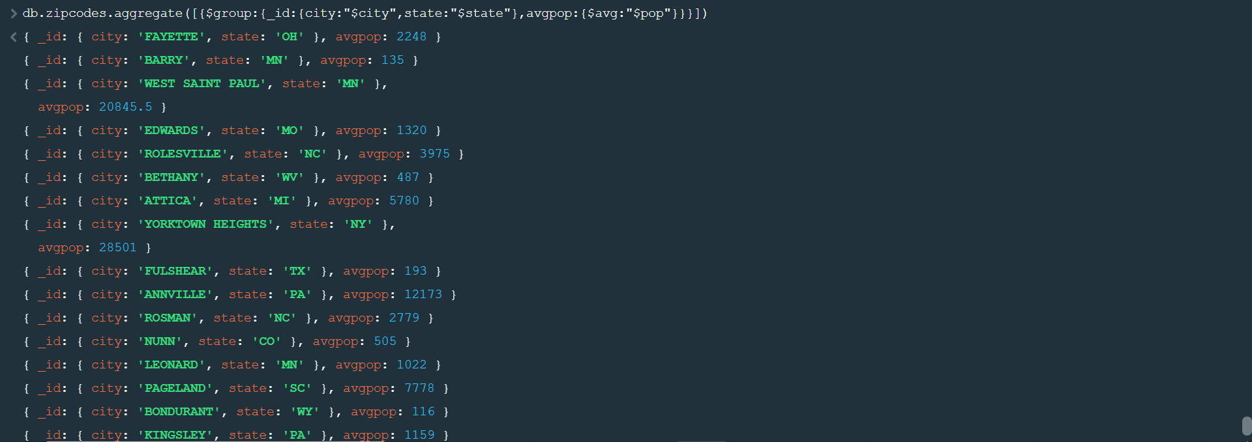

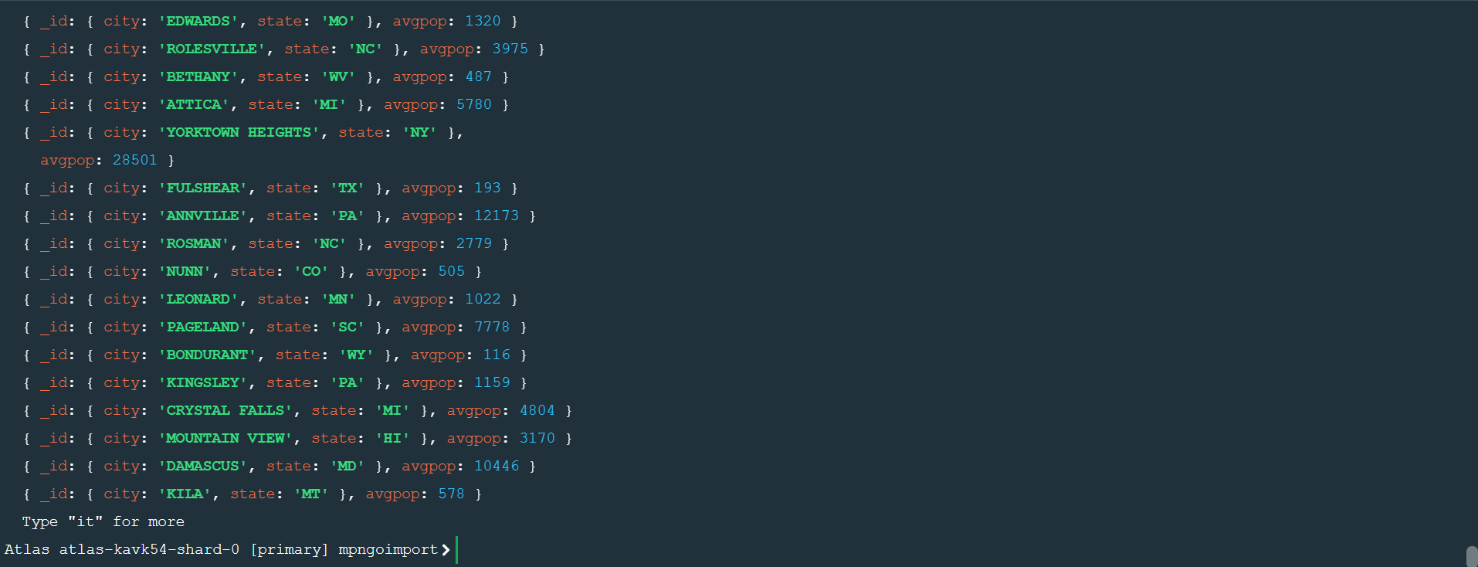

**Assignment-3**

**MongoDB – Complex Queries**

1.Download the restaurants. Zip file 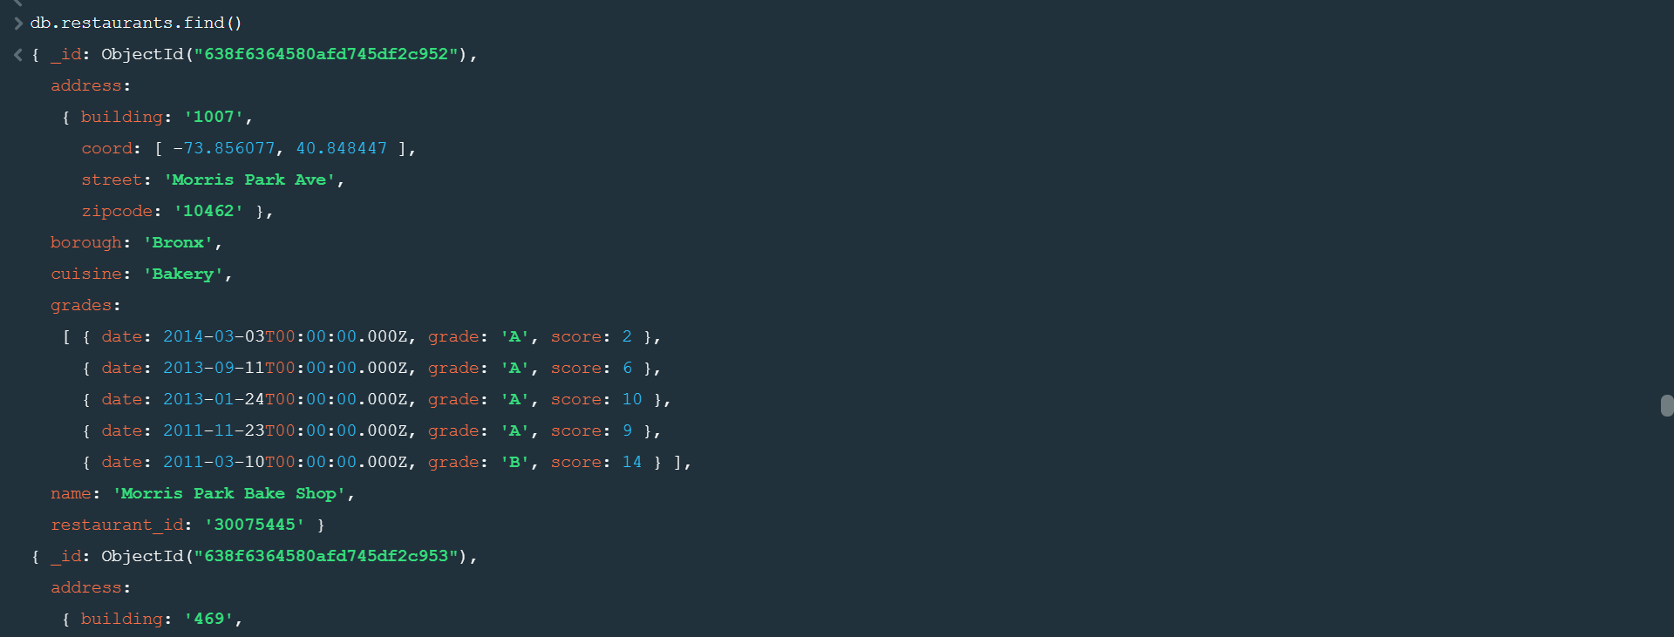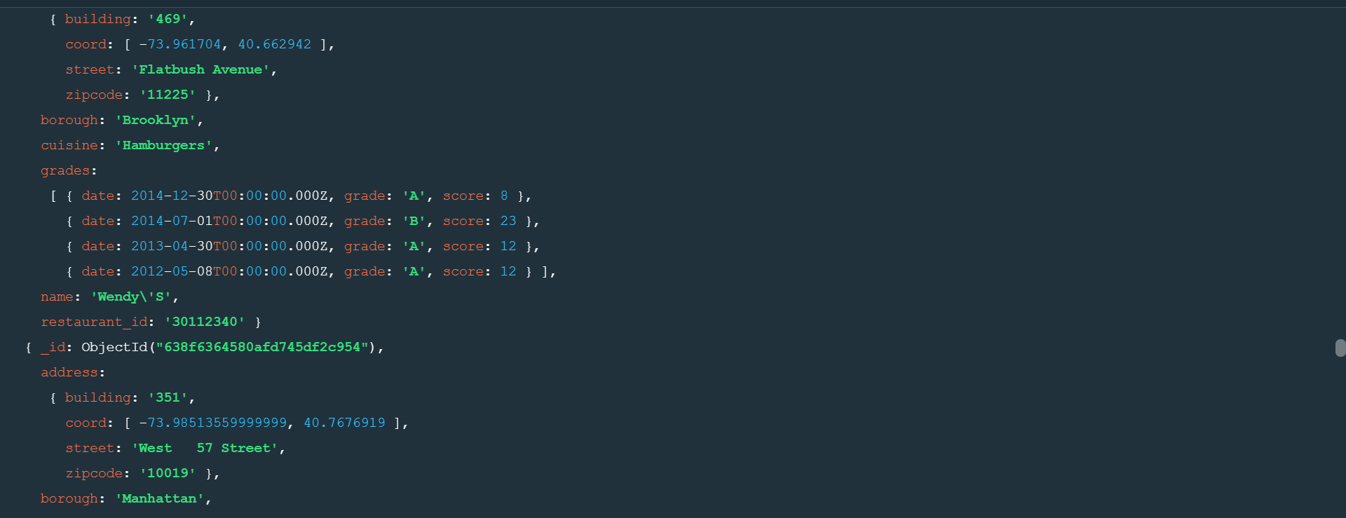

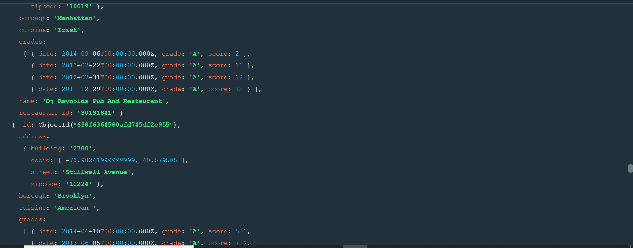

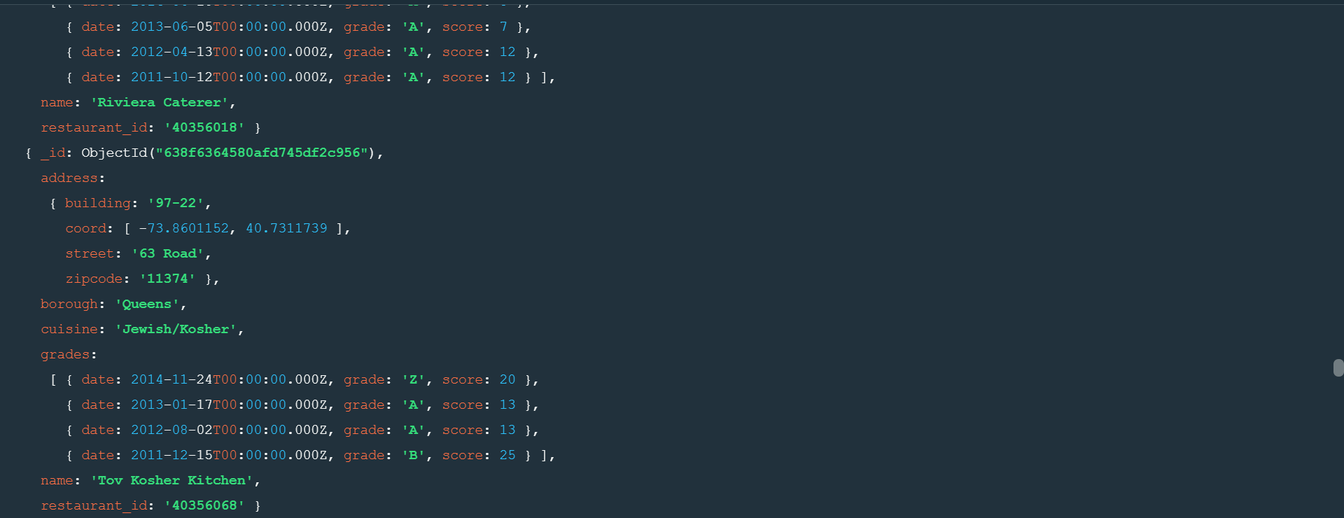

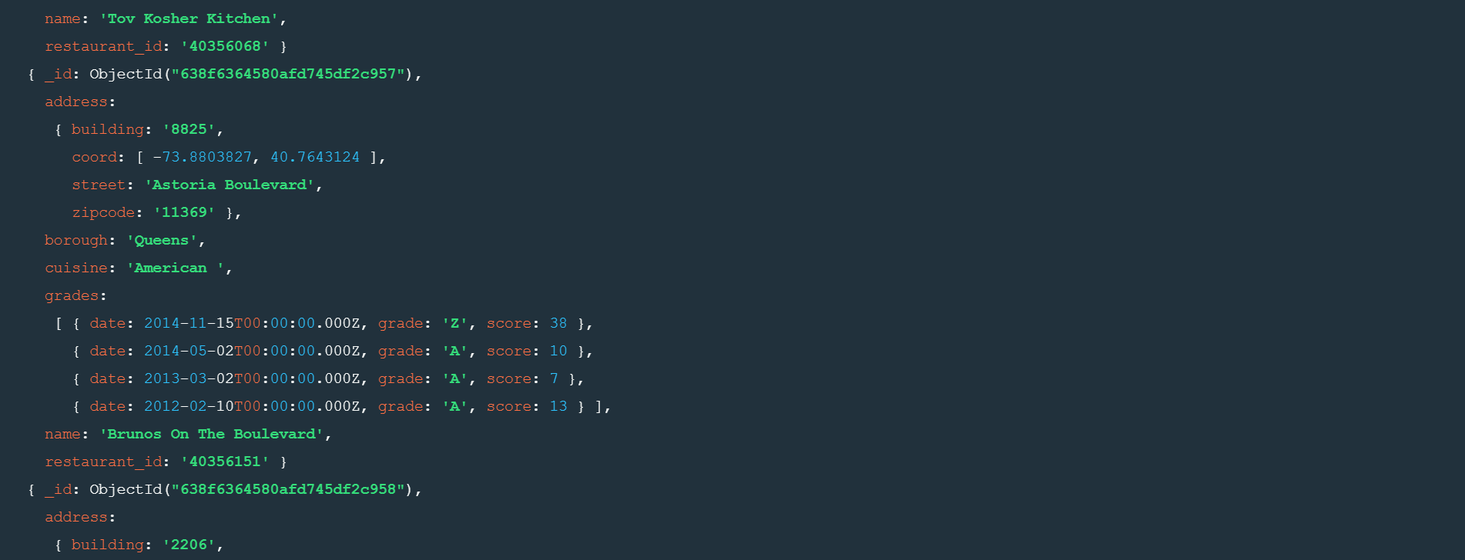

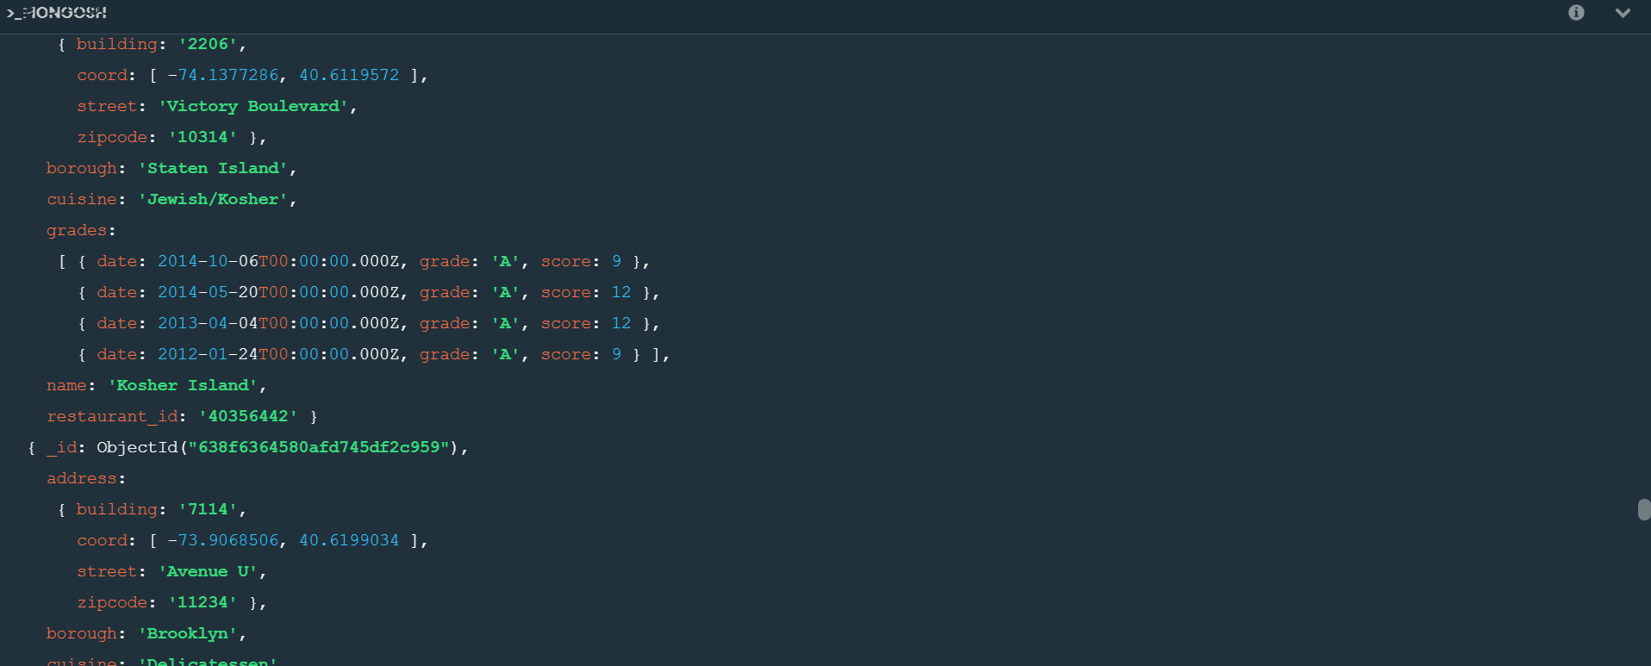

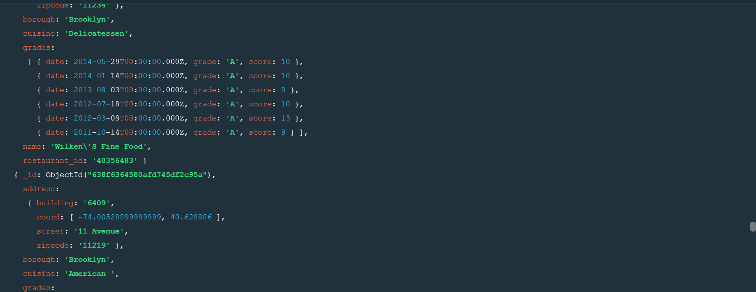

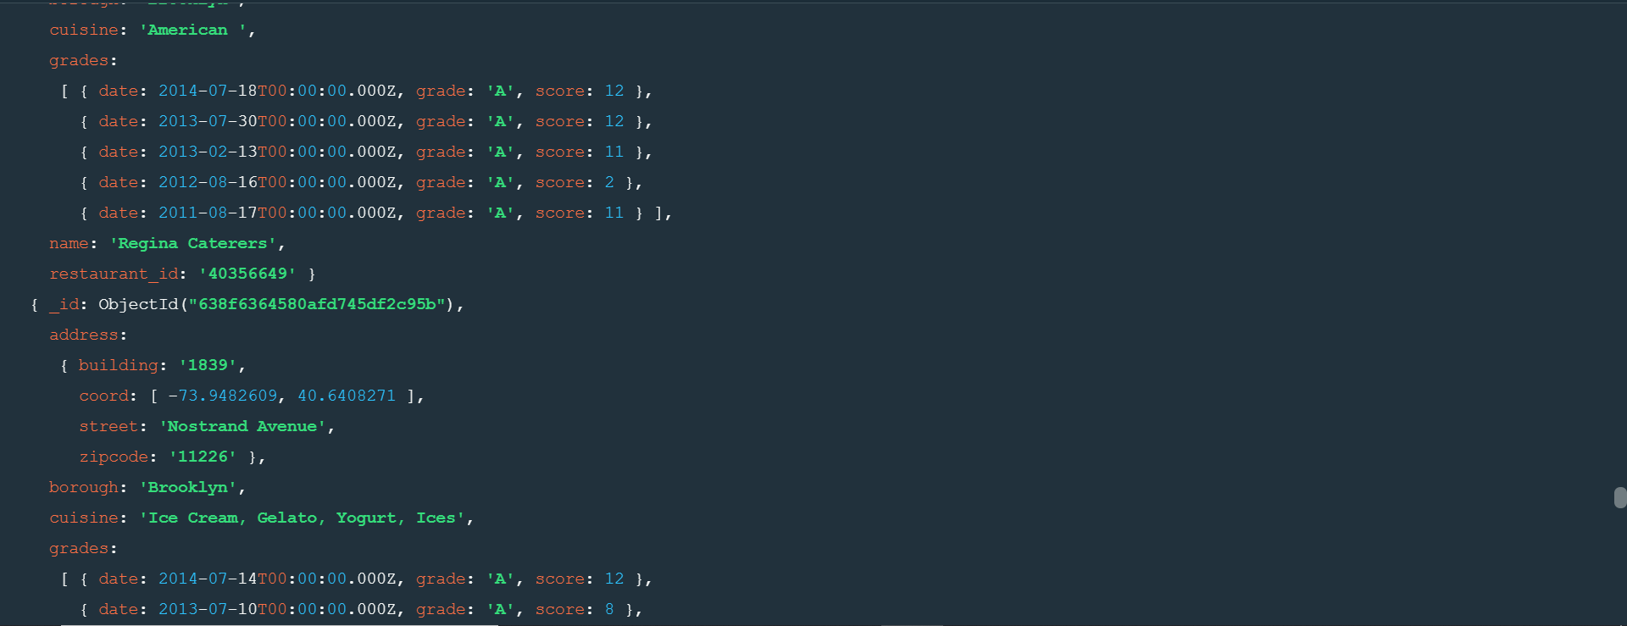

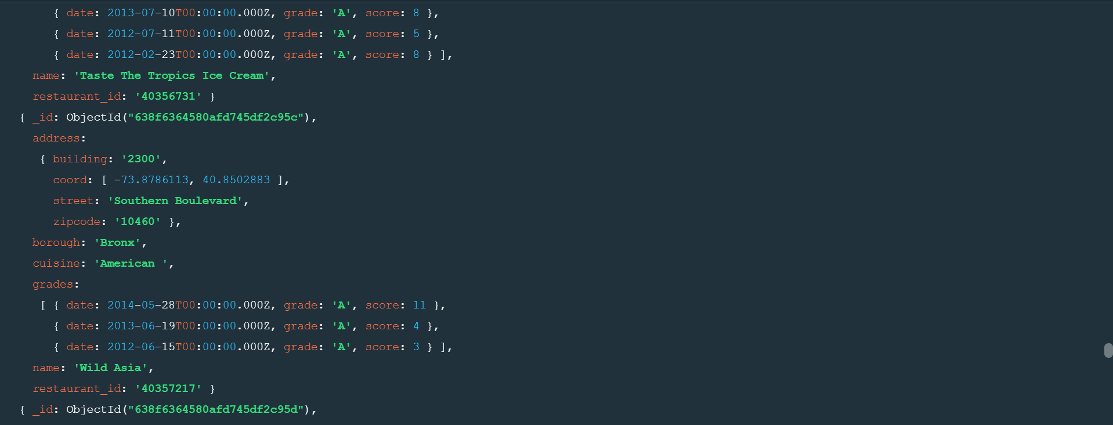

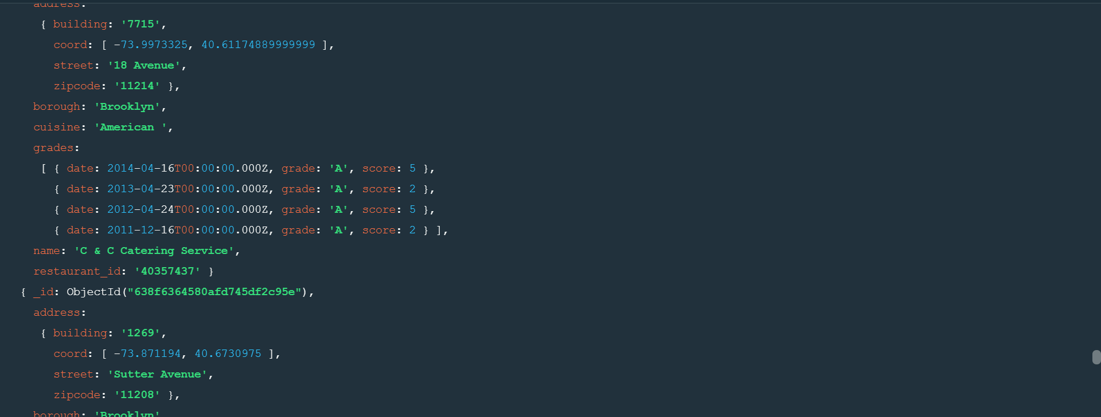

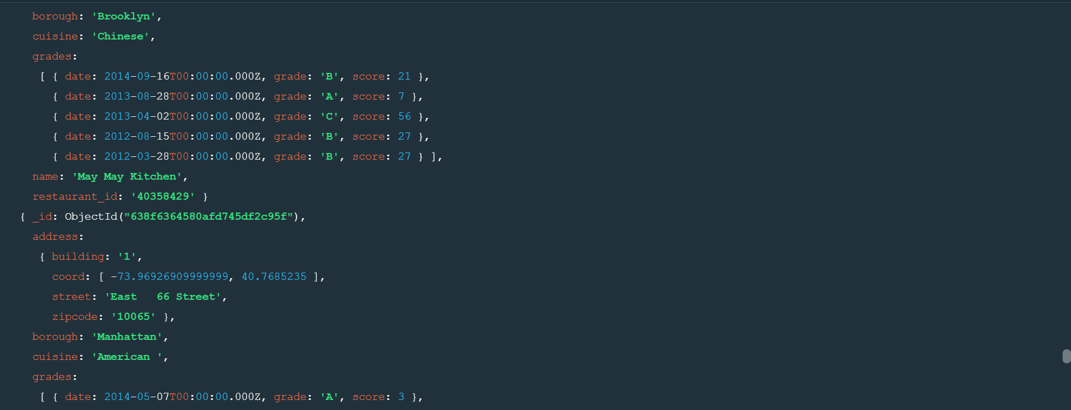

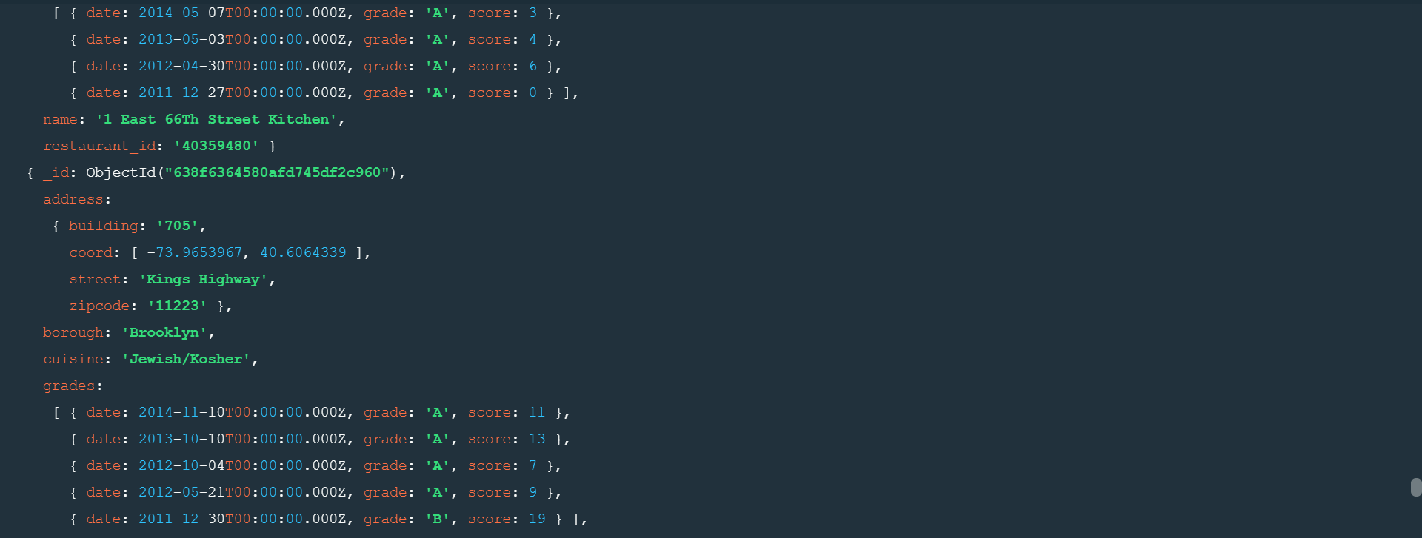

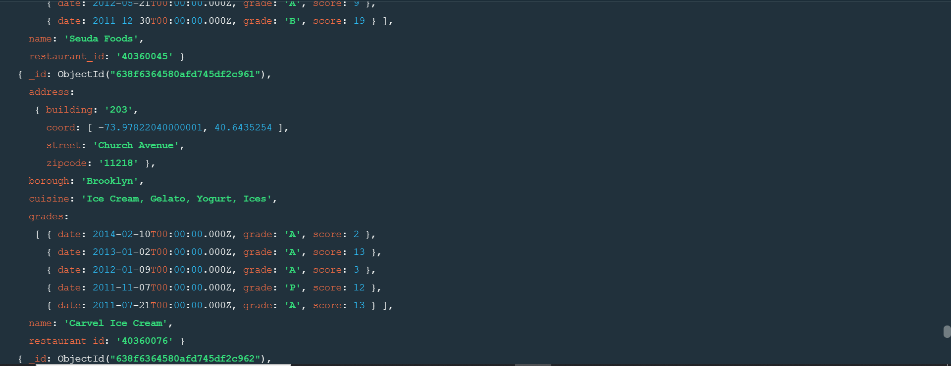

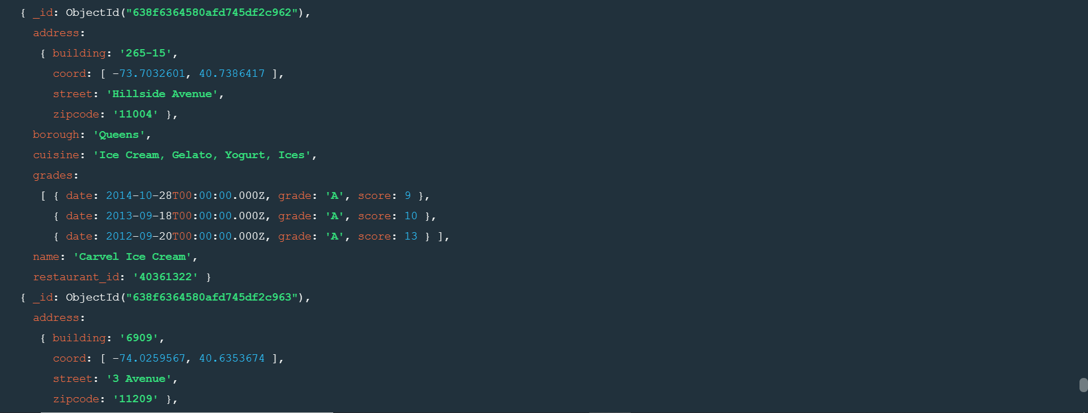

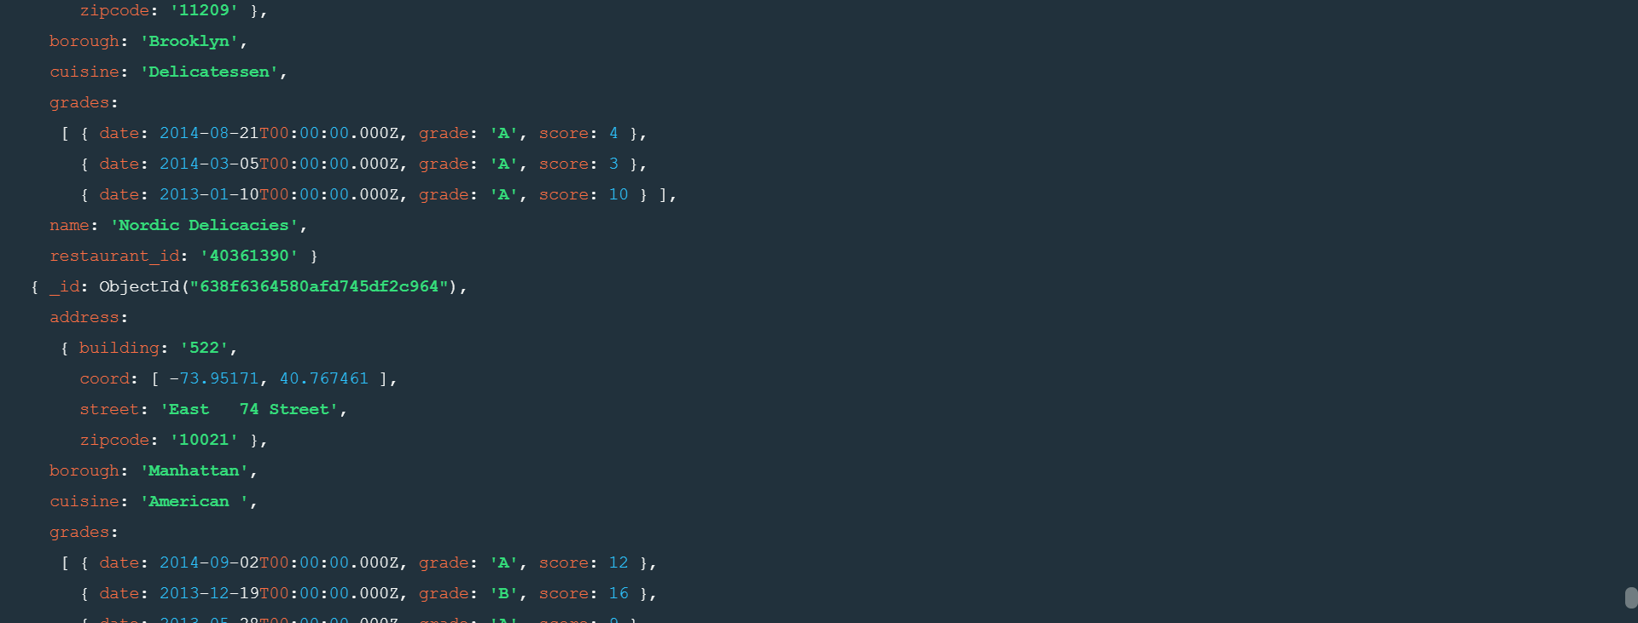

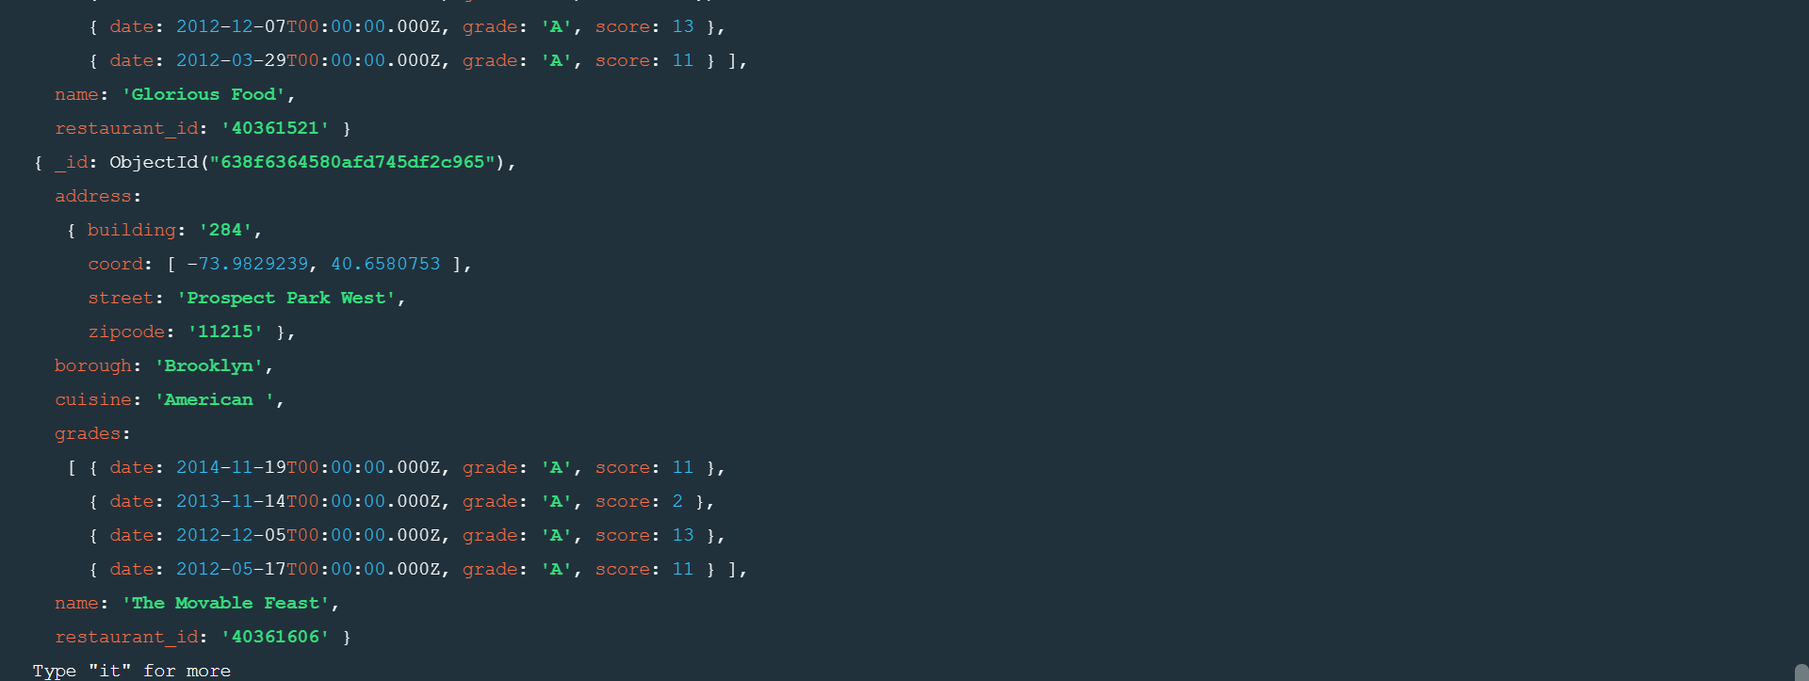

2.UnZip the file, you will see restaurants.json file

3.Run the mongod server

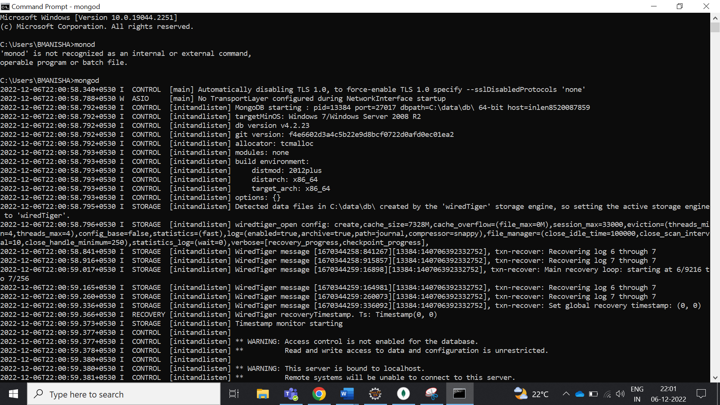

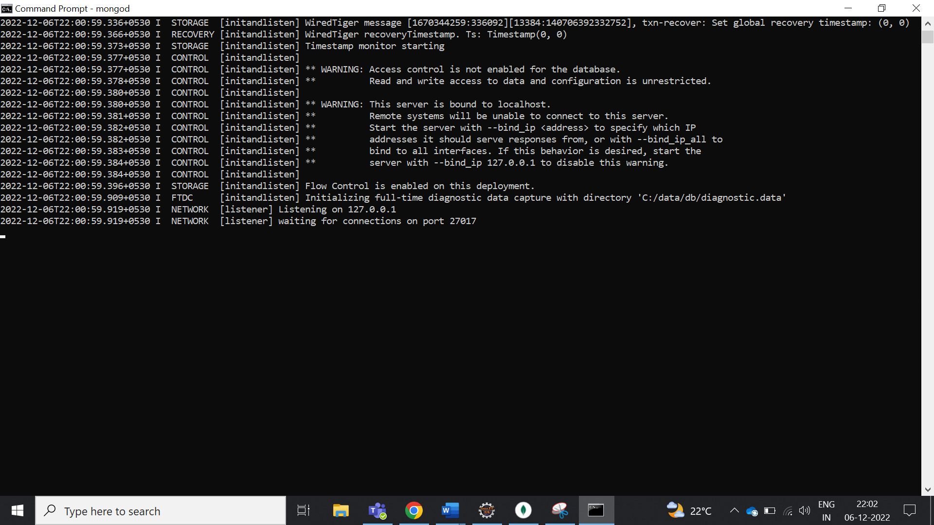

4.Run the following command to import the json file provided, it will load the json file into the mongodb with database name – restaurants,collections name - addresses

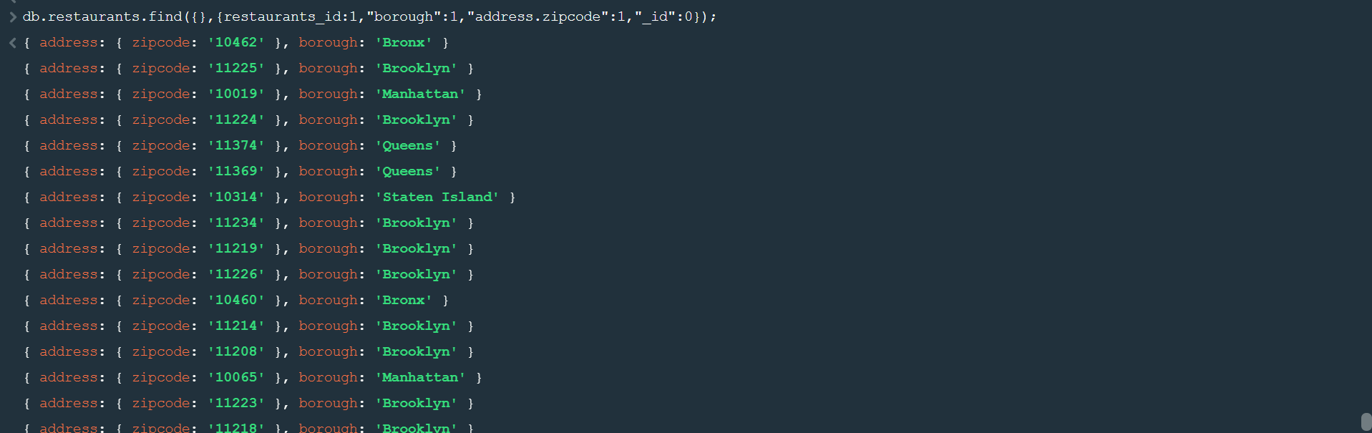

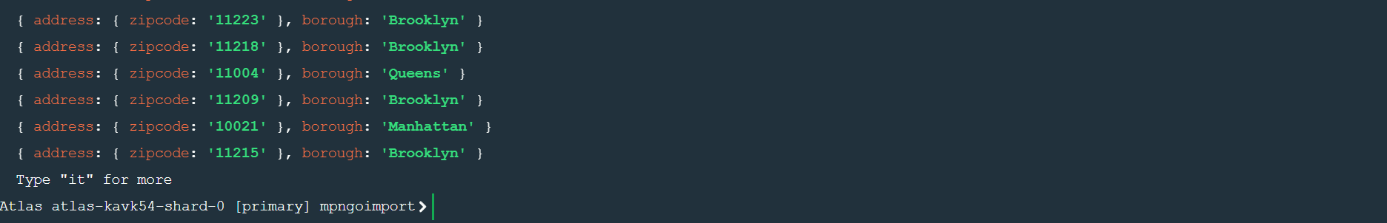

5. Run mongo shell command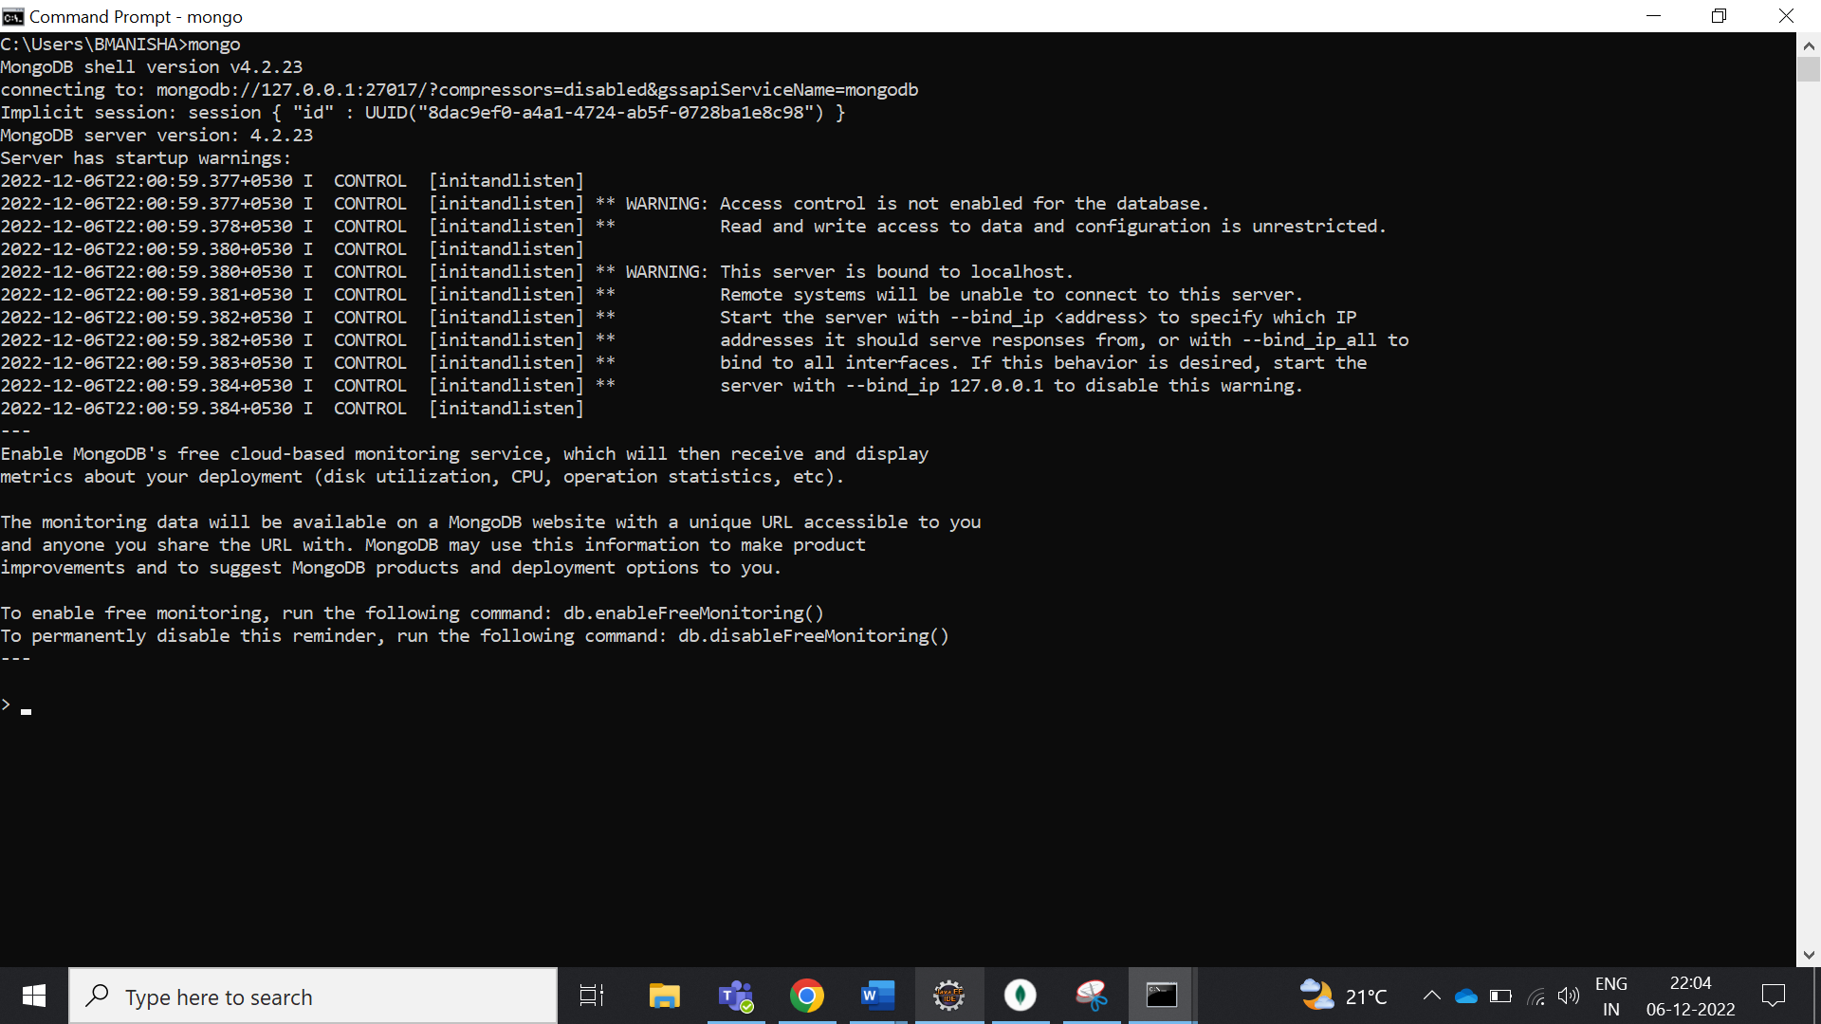

6. show data bases

